

BC Aboriginal Entrepreneurs:
A Growing Force
BC Aboriginal Small Business Profile



National 2002 AES Highlights
The majority of Aboriginal entrepreneurs nationally (72%) and provincially (69%) reported profits in 2002, with 36% of BC respondents reporting an increase in sales.
Nationally, the number of Aboriginal businesses operating in professional, technical, and social services has tripled since 1996. The number of manufacturing, transportation, and warehousing businesses was almost 5 times higher in 2001 than 1996. The youngest businesses were in professional, technical, and social services, where only 30% had been in business for 10 years or more.

Approximately 5 out of every 10 Aboriginal businesses had been in operation for 10 years or more in three sectors: primary industries; construction; and manufacturing, transportation and warehousing.

Aboriginal business owners in primary industries were the most likely to hire Aboriginal people, with 7 out of 10 reporting one or more Aboriginal employee.

Nationally, nearly two-thirds of Aboriginal business owners (63%) anticipated growth in the next two years.

Aboriginal Entrepreneurs Survey Background
The Aboriginal Entrepreneurs Survey was conducted by Statistics Canada in the fall of 2003 on behalf of Industry Canada’s Aboriginal Business Canada program.
Target Population: The Aboriginal Entrepreneurs Survey 2002 covers all individuals living in households in Canada where in the 2001 Census of Population; one or more members of the household were identified as being self-employed Aboriginal people. Households located both on and off-reserve were included. The estimates contained in these tables were generated from the responses of individuals who in 2002:

- were identified as self-employed Aboriginal people in the 2001 Census; and
- indicated that they owned and operated a business for at least some period time in 2002

Data Collection: The survey estimates were generated from the responses obtained from 1126 Aboriginal entrepreneurs. The collection which took place during the fall of 2003 was conducted mostly via Computer Assisted Telephone Interview although, in a small number of cases, paper questionnaires were mailed out and mailed back. The response rate was revised and established at 36%.

The Aboriginal Business Service Network – BC Region (ABSN BC) is a program administered through the Community Futures Development Association and supported by Western Economic Diversification.

The ABSN BC Steering Committee, which guides the delivery of the ABSN in BC, is made up of Aboriginal business service providers, federal, provincial, and non-profit representatives with the mission to assist Aboriginal peoples to realize their economic goals by improving access to and use of business information and services.

For more information on the Aboriginal Business Services Network – BC Region, please contact Laara Mixon, Manager, ABSN BC, @ 604-685-2330 or email absn@firstbusiness.ca.

Statistics Canada’s Aboriginal Communications Program is administered by Statistics Canada’s Western Region and Northern Territories.
The goal of the Aboriginal Communications Program is to increase access to and understanding of Statistics Canada’s data; build statistical capacity within Aboriginal communities through statistical training; and develop Statistics Canada’s capacity to respond to the information needs of Aboriginal peoples.
For more information on the 2002 Aboriginal Entrepreneurs Survey and other information from Statistics Canada, please contact Mary McNeill, Aboriginal Communications Officer, Statistics Canada @ (604) 666-4996 or Mary.McNeill@statcan.ca.

Note of Appreciation
Canada owes the success of its statistical system to a long-standing co-operation involving Statistics Canada, the citizens of Canada, its businesses, governments and other institutions. Accurate and timely statistical information could not be produced without their continued cooperation and goodwill.

Introduction

Aboriginal self-employment is growing steadily in British Columbia and across Canada. This profile of Aboriginal self-employment in British Columbia is drawn from information from the 2002 Aboriginal Entrepreneurs Survey (AES) and the 2001 Census.

The Aboriginal Entrepreneurs Survey, which was sponsored by Industry Canada (Aboriginal Business Canada), explored a range of topics with a sample of Aboriginal business owners: business objectives and growth expectations, business financing and financial information, employee characteristics, markets, business training, and barriers to growth.

This information is a recommended key strategic document for Aboriginal groups, organizations, and First Nations along with their partners in the public and private sector when planning for the provision of programs and/ or services for Aboriginal entrepreneurs.

Throughout this report, please note that although BC represents 170,025 (and 4.4% of the BC population) or 17.4% of the nation’s Aboriginal population, that 25% of AES respondents were from BC or the Yukon.

Summary of Key Findings:

- BC Aboriginal entrepreneurs are a strong and growing force in BC demonstrating diversification across industries and sustainability.
- BC Aboriginal entrepreneurs are young, with over one quarter under the age of thirty-five.
- BC Aboriginal entrepreneurs are primarily micro-entrepreneurs who operate full-time businesses across all industry sectors .
- BC Aboriginal entrepreneurs focused primarily on local markets to sell their goods and services, with many planning to expand into foreign markets.
- BC Aboriginal entrepreneurs tended to self-finance their own businesses rather than formal types of financing such as debt leasing.

2001 Census Profile: BC Aboriginal Population Younger and Growing…

Between 1996 and 2001, BC’s Aboriginal population grew 26%, a rate 5 times higher than the overall BC Aboriginal population which grew at a rate of 5%.

Nearly one-third (30%) of the BC Aboriginal population was under the age of 14 compared to 18%, the corresponding share of the overall BC population. Although the Aboriginal population accounts for 4.4% of BC’s total population, Aboriginal children under the age of 14 represent 7.3% of all children in BC.

Approximately three-quarters of the BC Aboriginal population lived in off-reserve urban and rural areas.
(Source: Statistics Canada: 2001 Census)

BC Aboriginal Entrepreneurs
A Growing Force

Since 1996, the number of self-employed Aboriginal people in BC has increased by 33%.

- In 2001, 6485 BC Aboriginal people were self-employed

- Self-employment was slightly higher for Aboriginal males (60%) than for Aboriginal females (40%)

- Seventeen percent (17%) of self-employed Aboriginal people resided on-reserve, while 83 % resided off-reserve

- Self-employment is higher for Aboriginal women off-reserve (41%) than on-reserve (33%)

- Self-employment was equally urban and rural based with 55% urban-based and 45% rural-based.

- Over one quarter of BC Aboriginal entrepreneurs were under the age of 35. The median age for Aboriginal entrepreneurs was 35-44, while it was 45 – 54 for British Columbians overall.

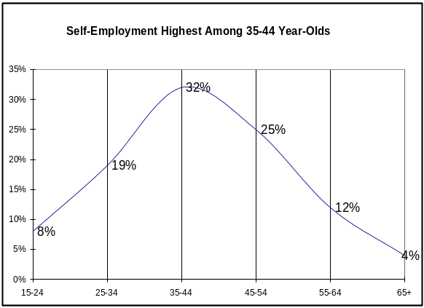

(Source: Statistics Canada: 2001 Census)

Creating Local Community Growth…
Community development depends heavily on small business and in BC most Aboriginal businesses surveyed focused on local markets to sell their products and services.
In BC, over half of Aboriginal entrepreneurs surveyed sold more than 75% of their goods and services in their local community.
Further, approximately half of respondents reported to sell some goods and services within BC.

Creating Employment…

Overall, just under one-third (30%) of Aboriginal businesses had one or more full-time employees, while over one-quarter (28%) had one or more part-time employees.

Grass Roots, home-based businesses..

In BC, 2/3 of Aboriginal businesses surveyed (66%) operated under a sole proprietorship structure, while 19% operated under a partnership, and 16% were incorporated.

The majority (78%) of BC Aboriginal entrepreneurs were home-based.

Sustainable Business…

Over half of new Canadian businesses that fail do so in the first two years 1. Approximately two-thirds (68%) of BC’s Aboriginal businesses surveyed had been in operation for more than five years.

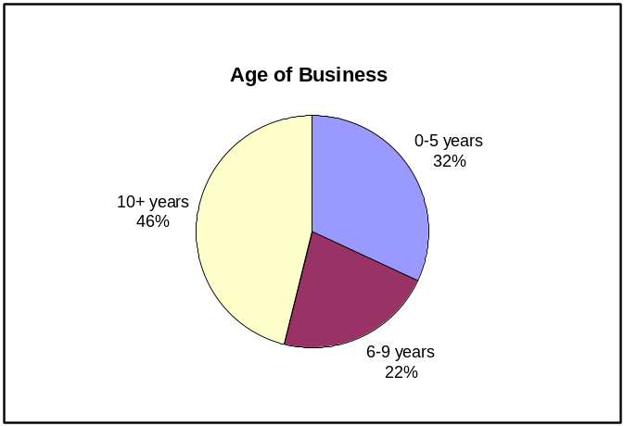

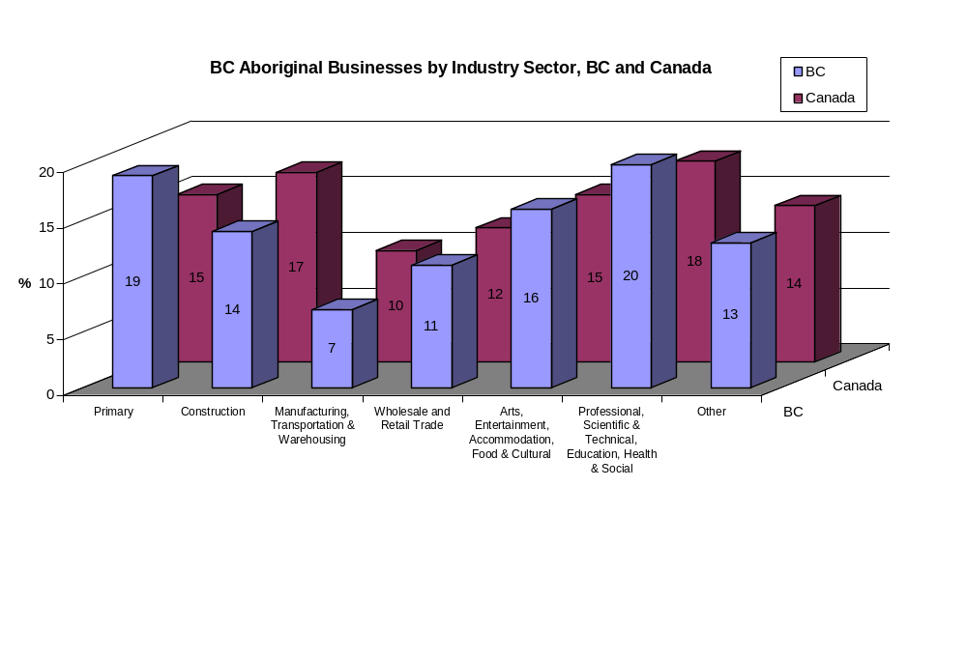
Increasing Success across a Wide Range of Industry Sectors…
Aboriginal Business Trends:

Growth and Innovation…
Nationally, nearly two-thirds of Aboriginal business owners (63%) anticipated growth in the next two years. In BC, 70% of Aboriginal entrepreneurs anticipated growth.
Over half of national and BC respondents stated they operated in a competitive industry.
In the past two years, 52 % of entrepreneurs surveyed innovated – that is, they introduced new products or processes in their business.

Growing Profits…

Sixty-nine percent (69%) of BC Aboriginal businesses surveyed reported net profits in 2002.

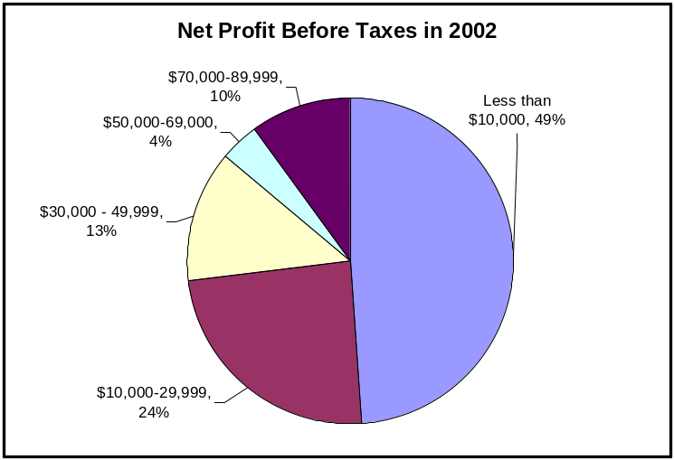

The industry graph above shows that both nationally and provincially, AES respondents represented Aboriginal business activity across a wide range of clusters.

Finding the Dollars to Start…

Most (89%) BC Aboriginal businesses surveyed started up on their own or with partners, with half self-financing their own start up costs.

Only 33% of BC Aboriginal entrepreneurs borrowed 50% or more of their start-up funds.

% of Borrowed Start-up Funds | %
0% | 50%
Less than 10 % | 5%
10% to 24% | 5%
25% to 49% | 8%
50% to 74% | 15%
75% to 99% | 10%
100% | 8%

Personal savings, retained earnings, and loans or lines of credit from financial institutions were the most frequently used sources of financing:

Sources of Financing | Start-up | 2002 | Future
Loans or lines of credit from financial institutions | 30% | 31% | 38%
Credit unions | 10% | 9% | 15%
Commercial or Personal Credit cards | 18% | 26% | 27%
Aboriginal Lending Organizations | 9% | 7% | 28%
Credit from Government Programs | 10% | 3% | 14%
Leasing | 9% | 4% | 6%
Personal Savings | 87% | 50% | 40%
Loans or equity from friends or relatives | 17% | 5% | 7%
Retained earnings | n.a. | 63% | 67%
Other | 4% | 2% | 2%

Amount Required for Financing…

The majority (85%) of BC Aboriginal entrepreneur respondents reported requiring less than $50,000 to start their business.

Amount | BC | Canada
Less than $5,000 | 35% | 34%
$5,000 to $9,999 | 12% | 13%
$10,000 to $24,999 | 30% | 22%
$25,000 to $49,999 | 9% | 11%
$50,000 to $99,999 | 7% | 9%
$100,000 or more | 12% | 11%

Barriers to Growth…

BC Aboriginal entrepreneurs reported the overall economy and government policy, rules, and regulations as the top barriers to business growth:

Barriers to Growth | %
Overall economic conditions | 42%
Government policy, rules and regulations | 39%
Cost of doing business | 36%
Taxes | 34%
Access to financing | 34%
Access to equity or capital | 30%
Availability of skilled labour | 30%
Competition | 28%
Cost of borrowing | 26%
Infrastructure (e.g. telephone) | 20%
Access to technical assistance | 18%
Trade regulations or exchange rate | 17%

In 2002, only 3% of BC Aboriginal businesses surveyed temporarily or permanently closed their doors. Factors reported to have contributed to business closure were personal situation (e.g. illness, family matters) (75%), cost of doing business (68%), and access to financing (58%).

Business Strategies…

In 2002, nearly one in five business owners had a written business plan to achieve their goals. Business plans included the following components as follows:

Financial plan | 92%
Human resources plan | 60%
Marketing plan | 88%
Product development plan | 61%

Business Plans and Skills Training…

Of those who took small business training (30%), accounting/bookkeeping, business administration, and developing a business plan were the most popular courses.

Accounting/bookkeeping | 67%
Business administration | 49%
Developing a business plan | 45%
Management practices | 44%
Marketing | 44%
Finance | 41%
Economics | 36%
Starting a business | 32%
Apprenticeship | 9%
Other | 33%

Lifelong learners…

BC Aboriginal entrepreneurs reported wanting to improve their skills in the following areas:

Production | 67%
Ability to effectively use technology | 67%
Marketing | 60%
Financing | 59%
Competitive strategy | 55%
Research and development and innovation | 53%
Human resources | 42%

Support wanted…

To maintain stability and increase profits, AES respondents stated they would seek the following types of assistance:

Business development funding/loans/financial support | 85%
Establishing business contacts | 57%
Market information | 55%
Information on business opportunities | 50%
Training/Skills Development Programs | 53%
Government Sales Contracts (procurement programs) | 40%

Support sources…

In 2002, the majority of AES respondents in BC (80%) stated that they did not receive assistance from government or Aboriginal organizations; however, in future they would look for help from:

Aboriginal Business Canada | 50%
INAC | 35%
Provincial departments involved in Business/Economic Development | 30%
Band/Economic Development Officer | 30%
HRDC | 30%
Canada Business Service Centres | 28%
Western Economic Diversification | 26%
Natural Resources Canada | 14%
Aboriginal Capital Corporation | 20%
Other | 15%

Business Goals of Profit and Stability…

BC Aboriginal entrepreneurs rated stability (86%) and profitability (80%) as their most important business objectives, followed by personal and family employment (75%) and growth (59%).

Reference Notes
Aboriginal Groups
In Canada, the Aboriginal population consists of three broad groups: Inuit, Métis and North American Indian. Even within these groups, there is much diversity, as Aboriginal peoples across the country have many unique histories, cultures and traditions. Data from the AES have been tabulated for each of these three groups. The AES asked a question about Aboriginal identity that allowed for multiple responses. In other words, a respondent could identify as North American Indian, Métis and/or Inuit.

Self-Employment
The AES included only those Aboriginal people who indicated that they owned and operated businesses.

Urban and Rural Areas
Urban areas refer to those areas with a population of at least 1,000 and no fewer than 400 persons per square kilometre. Anything that is not an Urban Area is considered Rural.

Industry Groups
Client-defined industry groups are defined based on the 2002 North American Industry Classification System (NAICS) as follows:
AES Industry Group | 2002 NAICS Code | 2002 NAICS Description
Primary | 11 | Agriculture, Forestry, Fishing and Hunting
Primary | 12 | Mining and Oil and Gas Extraction
Construction | 23 | Construction
Manufacturing, Transportation & Warehousing | 31-33 | Manufacturing
Manufacturing, Transportation & Warehousing | 48-49 | Transportation and Warehousing
Wholesale and Retail Trade | 41 | Wholesale Trade
Wholesale and Retail Trade | 44-45 | Retail Trade
Arts, Entertainment, Accommodation, Food & Cultural | 71 | Arts, Entertainment and Recreation
Arts, Entertainment, Accommodation, Food & Cultural | 72 | Accommodation and Food Services
Arts, Entertainment, Accommodation, Food & Cultural | 51 | Information and Cultural Industries
Professional, Scientific& Technical, Education, Health & Social (1) | 54 | Professional, Scientific and Technical Services
 | 61 | Educational Services
 | 62 | Health Care and Social Assistance
Other | 52 | Finance and Insurance
Other | 53 | Real Estate and Rental and Leasing
Other | 55 | Management of Companies and Enterprises
Other | 56 | Administrative and Support, Waste Management and Remediation Services
Other |  | Other Services (except Public Administration)
Other | 81

1 Baldwin, John, Tara Gray, Joanne Johnson, Jody Proctor, Mohammed Rafiquzzaman, David Sabourin (November 1997) Failing Concerns: Business Bankruptcy in Canada. Statistics Canada Micro-Economic Analysis Division.

