 | Public Works & Government Services Canada  Shared Travel Services Initiative  Detailed Portal Guide for Travellers and Travel Arrangers  Release Version 6.0  Release Date: June 17, 2005

Table of Contents
1 Introduction 7
1.1 Background to Travel AcXess Voyage 7
1.2 Purpose of the Travel AcXess Voyage Portal Detailed Portal Guide 8
1.3 Intended Audience of the Travel AcXess Voyage Portal Detailed Portal Guide 8
1.4 Structure of the Travel AcXess Voyage Portal Detailed Portal Guide 9
2 Accessing the Portal as a New User 11
2.1 Entering the Portal 11
2.2 Obtaining a TIN 12
2.3 Determining your X.400 E-mail status 14
2.4 Completing the New User Setup 20
2.4.1 Step 1: Change My Password 25
2.4.2 Step 2: Viewing the Privacy Notice Statement 27
2.4.3 Step 3: Create my Profile 28
2.4.4 Step 4: Viewing the New User Set Up Confirmation Page 31
3 Accessing the Portal as a Returning Traveller 32
3.1 Entering the Portal 32
3.2 Logging In 34
3.3 Forgotten Password 35
3.4 Recovering your Forgotten TIN 38
3.5 Managing your Profile and Portal 39
3.5.1 Managing your Profile 39
3.5.2 Changing your Password 58
3.5.3 Changing Your Secret Question 61
3.5.4 Adding/Changing and Removing your X.400 E-mail address 65
3.5.5 Personalizing your Portal 76
4 Accessing the Portal as a Travel Arranger 79
4.1 Entering the Portal 79
4.2 Logging In 81
4.3 Managing your Traveller’s Profiles 82

Table of Figures
Table 1: Symbol Dictionary 6
Figure 2.1: Portal Language Selection Page 11
Figure 2.2: Portal Welcome Page 12
Figure 2.3: TIN Registration Request Form Page 13
Figure 2.4: TIN Registration Name Selection Page 15
Figure 2.5: TIN Registration Request Form Page 16
Figure 2.6a: TIN Registration Request Completion Page 17
Figure 2.6b: TIN Registration Request Completion Page 18
Figure 2.7: Portal Welcome Page 19
Figure 2.8: Portal Language Selection Page 20
Figure 2.9: Portal Welcome Page 21
Figure 2.10: Login Page 22
Figure 2.11: Secret Question and Answer Verification Page 23
Figure 2.12: New User Setup Welcome Page 24
Figure 2.13: Change my Password Page 25
Figure 2.14: Change my Password Confirmation Page 26
Figure 2.15: Privacy Notice Statement Page 27
Figure 2.16a : Create My Profile Page 28
Figure 2.16b: Create My Profile Page (Cont’d.) 29
Figure 2.17: New User Setup Confirmation Page 31
Figure 3.1: Portal Language Selection Page 32
Figure 3.2: Portal Welcome Page 33
Figure 3.3: Login Page 34
Figure 3.4: Login Page 35
Figure 3.5: Forgot Password Page 36
Figure 3.6: Forgot Password Confirmation Page for Travellers with an X.400 E-mail address 37
Figure 3.7: Forgot Password Confirmation Page for Travellers without an X.400 E-mail address 37
Figure 3.8: Forgot TIN Page 38
Figure 3.9: Portal Home Page 39
Figure 3.10: Profile/X.400 E-mail Page 40
Figure 3.11a: Department Profile Page 41
Figure 3.11b: Personal Profile Page (Cont’d.) 42
Figure 3.11c : Personal Profile Page (Cont’d.) 43
Figure 3.11d: Personal Profile Page (Cont’d.) 44
Figure 3.11e: Personal Profile Page (Cont’d.) 45
Figure 3.11f: Personal Profile Page (Cont’d.) 46
Figure 3.11g: Personal Profile Page (Cont’d.) 46
Figure 3.12a: Department Profile Page 47
Figure 3.12b: Department Profile Page (Cont’d.) 48
Figure 3.12c: Department Profile Page (Cont’d.) 49
Figure 3.13: Travel Arranger Search Page 50
Figure 3.12d : Department Profile Page (Cont’d.) 51
Figure 3.14a: Travel Preferences Profile Page 52
Figure 3.14b: Travel Preferences Profile Page (Cont’d.) 53
Figure 3.14c: Travel Preferences Profile Page (Cont’d.) 54
Figure 3.14d : Travel Preferences Profile Page (Cont’d.) 55
Figure 3.14e: Travel Preferences Profile Page (Cont’d.) 56
Figure 3.15: Traveller Profile Confirmation Page 57
Figure 3.16: Traveller Profile Submission Page 57
Figure 3.17: Home Page 58
Figure 3.18: Change Password Page 59
Figure 3.19: Change Password Confirmation Page 60
Figure 3.20: Home Page 61
Figure 3.21: Change Password/Change Secret Question Page 62
Figure 3.22: Change Secret Question Page 63
Figure 3.23: Change Secret Question Confirmation Page 64
Figure 3.24: Home Page 66
Figure 3.25: Profile Page 67
Figure 3.26: Add X.400 E-mail address Page 68
Figure 3.27: Add X.400 E-mail address Name Selection Page 69
Figure 3.28: Add X.400 E-mail address Confirmation Page 70
Figure 3.29: Add X.400 E-mail address Acceptance Page 70
Figure 3.30: Add X.400 E-mail address no Users Found 71
Figure 3.31: Contact Help Desk 71
Figure 3.32: Home Page 72
Figure 3.33: Profile Page 73
Figure 3.34: Changing X.400 E-mail address Page 74
Figure 3.35: Confirmation of X.400 E-mail address Removal Page 75
Figure 3.36: Home Page 76
Figure 3.37: Personalization Page 77
Figure 4.1: Portal Language Selection Page 79
Figure 4.2: Portal Welcome Page 80
Figure 4.3: Portal Login Page 81
Figure 4.4: Portal Home Page 82
Figure 4.5: Travel Arranger Profile Selection Page 83
Figure 4.6: Example of a Traveller’s Profile Page 84
Figure 4.7: Example of a Traveller’s X.400 E-mail Page 85

Legend
The following table lists the symbols that will be used throughout the detailed user guide.

Symbol | Name | Description
► | Activity | Instructions for an activity
 | Tip | Tip provided to the user
Bold | Interactive Object Reference | A reference to an interactive object inhe portal such as buttons, links, etc.
Italics | Page Name | A reference to a page in the portal.
Table 1: Symbol Dictionary

1 Introduction

The Travel AcXess Voyage portal is a Web-based, single point of access solution that integrates different travel-related tools, information and services, allowing travellers to gain access to, and personalize content in a secure environment.

1.1 Background to Travel AcXess Voyage

Under the Shared Travel Services Initiative (STSI), the contract for the delivery of government travel services was awarded to a new supplier, Accenture, and its team of subcontractors American Express, Concur Technologies and Bell Canada. Collectively, the services provided by the new contractor and subcontractors are known as Travel AcXess Voyage.

When Travel AcXess Voyage is fully implemented, employees will benefit from an automated and integrated travel experience – from start to finish. With a new full-service travel agency, an on-line booking tool, a convenient government travel card, responsive 24/7 traveller support and eventually an automated authorization and expense management tool. Employees will be able to manage travel simply and efficiently.

The On-line Booking Tool (OBT) allows employees to book travel from their desktop. Travellers can use the OBT to maintain their Profiles and to review and reserve travel. Itinerary confirmation and e-tickets are automatically handled through secure e-mail if the traveller has a valid X.400 E-mail address. The definition for the X.400 E-mail is in the Determining Your X.400 E-mail Status section.

The Full Service Travel Agency is accessible via a dedicated Government of Canada telephone line, a facsimile line and X.400 E-mail. Advanced telephone and interactive voice response systems determine caller requirements in order to route each caller to a skilled travel counsellor. Itinerary confirmation and tickets can be sent through X.400 E-mail, by facsimile or by mail, at a date and time established by the travel counsellor and traveller or Travel Arranger.

Versatility of Access
Travellers can choose how they access Travel AcXess Voyage services. At certain times, it may be beneficial to use the OBT to research and book travel; at other times, such as when travelling internationally, it may be preferable to use the travel agency. The OBT is the ideal tool for booking domestic and trans-border travel. The Full Service Travel Agency is recommended for complex international travel.

1.2 Purpose of the Travel AcXess Voyage Portal Detailed Portal Guide

The Detailed Portal Guide is intended to show travellers how to create a Profile and start using the portal for the first time. The Detailed Portal Guide outlines procedures and tips that will help travellers to use the portal successfully and is intended as a reference to help travellers who are returning to the portal to complete and update their traveller Profile, to navigate within the portal, and to personalize the portal to suit their needs.

1.3 Intended Audience of the Travel AcXess Voyage Portal Detailed Portal Guide

The intended audience of the Travel AcXess Voyage portal Detailed Portal Guide is all Government of Canada travellers who intend to use Travel AcXess Voyage services.

1.4 Structure of the Travel AcXess Voyage Portal Detailed Portal Guide

The Detailed Portal Guide is structured in three main sections:
- Accessing the Portal as a New User
- Accessing the Portal as a Returning Traveller
- Accessing the Portal as a Travel Arranger
Section 1) of the Detailed Portal Guide covers the following subjects:

2.1 Entering the Portal
2.2
Requesting a TIN
2.3
Completing the New User Setup
Section 2) of the Detailed Portal Guide covers the following subjects:

3.1 Entering the Portal
3.2
Logging In
3.3
Managing your Profile

Section 3) of the Detailed Portal Guide covers the following subjects:

4.1 Entering the Portal
4.2
Logging In
4.3
Managing Travellers’ Profiles

2 Accessing the Portal as a New User

A new user is a person encountering the Travel AcXess Voyage portal for the first time. As a new user, you will initially not have a Traveller Identification Number (TIN) nor will you have a Traveller Profile. New users can acquire both a TIN and a Traveller Profile by following these setup instructions.

2.1 Entering the Portal

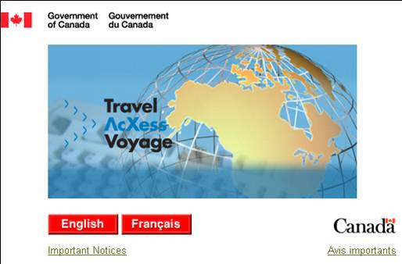
Figure 2.1: Portal Language Selection Page

► Accessing the Portal

1. Enter the following URL into the address bar of the browser:
http://travel-voyage.gc.ca;
2. Select English or Français;

► Adding Travel AcXess Voyage to your browser’s Favourites List

1. Select Favourites or Bookmarks on the toolbar of the browser;
2. Select Add to Favourites or Bookmarks

2.2 Obtaining a TIN

Once you have selected your language, the portal Welcome page is displayed. To log in, you need a Traveller Identification Number (TIN). A TIN is a unique number assigned to each traveller who uses Travel AcXess Voyage. A TIN allows travellers to access Travel AcXess Voyage, make changes to their Traveller Profile, and book travel.

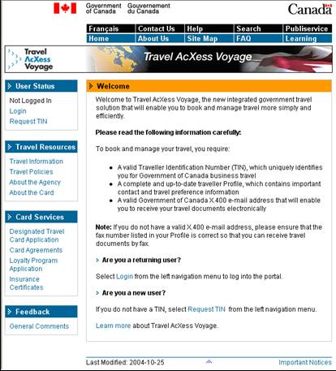

Figure 2.2: Portal Welcome Page

In order to log into the portal as a new user you must first request a TIN. The procedure for requesting your TIN is outlined in the following section.

► Requesting a TIN

- Select Request TIN on the left navigation bar.

Once you have selected Request TIN, the TIN Registration Request Form page will be displayed.

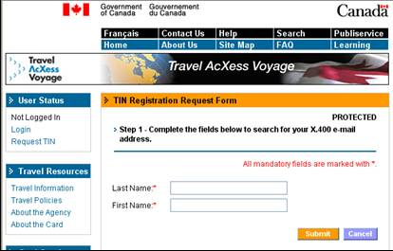

Figure 2.3: TIN Registration Request Form Page

► Searching for a Registered TIN

- Enter a Last Name;
- Enter a First Name;
- Select Submit.

The portal performs a search against a master employee database to try and locate you. If you have a unique name, your list will most likely contain one option. If you have a common name, you may have multiple options to select from.

Tips: 1. If you want to broaden your search, you can use a wild card character (*). For
example, if your last name starts with ‘D’, and you want to view all names starting
with ‘D’ you must enter ‘D*’ into the Last Name field.
2. Free form text fields can accept alphanumeric characters (letter A to Z and numbers
0 to 9), dashes (-), slashes (/), and asterisks (*). Periods are not accepted by the
system.
3. All fields marked with an asterisk are mandatory and must be
completed.
4. The portal restricts the maximum number of characters that can be entered in the name fields. The maximum number of characters for Salutation First Name, Middle Initial and Last Name combined is 40.

Determining your X.400 E-mail status

What is the X.400 E-mail?

X.400 E-mail is a secure Government of Canada e-mail system. A valid X.400 E-mail address is required to receive travel-related documents from Travel AcXess Voyage by e-mail; if you do not have an X.400 E-mail address, you will receive these documents by fax.

What does an X.400 E-mail address mean for you?

All system-generated e-mails from Travel AcXess Voyage are sent to travellers’ X.400 E-mail accounts

If you don’t have an X.400 E-mail, you can still use the system; however, notifications such as your travel itineraries will not be received by e-mail. You must request that your travel documents be sent to you by fax. Such a request must be made to the Travel AcXess Voyage Support Desk.

How do you determine weather or not you have an X.400 E-mail address?

You can perform a search for yourself in theX.400 database through the portal’s New User Setup or Request TIN process, or, after logging in, through the Profile/X.400 E-mail link in the User Status portlet on the left navigation bar.

If your name does not appear in Step 2 of the Request TIN process then you may not have an X.400 E-mail address.

If you cannot find your X.400 E-mail address, you will be asked to contact the Travel AcXess Voyage Support Desk by phone to obtain your TIN and Temporary Password.

If you are still unsure as to whether you have an X.400 E-mail address, please contact the Travel AcXess Voyage Support Desk to determine the status of your X.400 E-mail address.

Once you have selected Submit, Travel AcXess Voyage will search for your name. The results of the search are displayed on the following Web page.

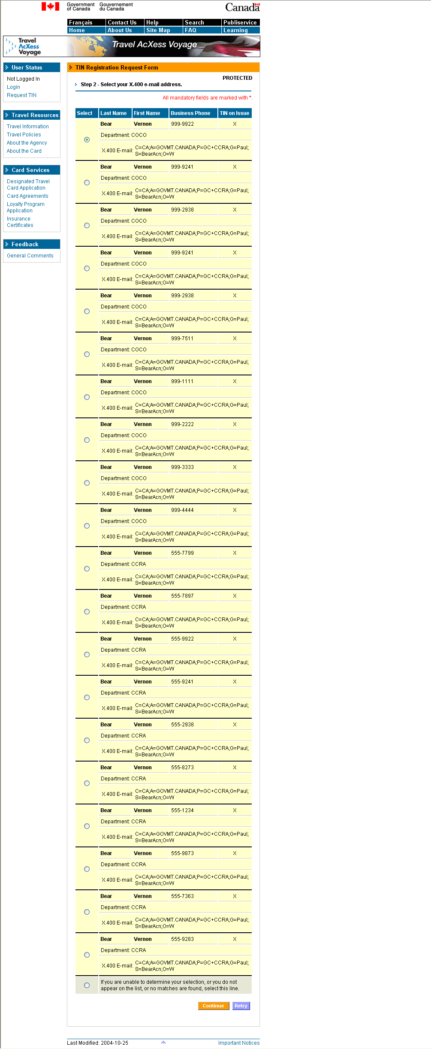
Figure 2.4: TIN Registration Name Selection Page

► Searching For a Registered TIN (Cont’d.)

- Select the applicable name;
- Select Continue.

Or if your name does not appear:
- Refine the search by selecting Retry or:
- Select the section indicating that you are unable to make your selection and
- Select Continue.

Once you have submitted your name, you will be directed to the next step of the TIN registration process.

Tip: 1. If the user is unable to locate themselves from the list, they can either select the Retry
button to attempt to locate their identity again, or they can select the Continue
button to proceed. If you do not see your name in the list of resulting names, select
the ‘If you are unable to determine your selection’ box and then select Continue to
complete the registration process. At the end of the process, you will be directed to contact the Travel AcXess Voyage Support Desk to obtain your TIN and Temporary Password. For an explanation of the X.400 E-mail please see the previous page.

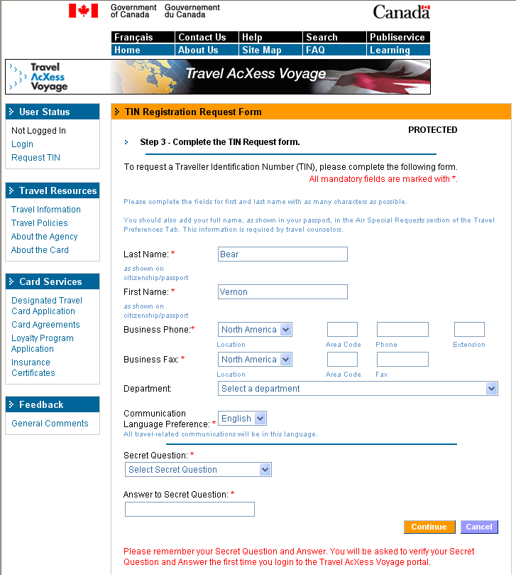

Figure 2.5: TIN Registration Request Form Page

► Completing the Registration Request Form

- Enter a Last Name (as it appears on the user’s citizenship or passport) if no X.400 E-mail was selected previously;
- Enter a First Name (as it appears on the user’s citizenship or passport) if no X.400 E-mail was selected previously;
3. Enter a Business Phone number;
4. Enter a Business Fax number;
5. Select a Department name from the drop-down list;
6. Select a Communication Language Preference from the drop-down
list;
7. Select a Secret Question from the drop-down list;
8. Enter a Secret Answer;
- Select Submit.

The Secret Question and Answer are to be used as a security measure to verify your identity when you log into the portal for the first time. The Secret Question and Answer can also be used in case you forget your password to verify your identity.

Tips: 1. Your First and Last Names will be pre-populated in their appropriate fields.
2. All fields marked with an asterisk are mandatory fields and must be completed.
3. The Communication Language Preference will determine the language of any
travel-related documents sent to you.
4. The Secret Answer is case-sensitive.

Once you have selected Submit and you have a valid X.400 E-mail address, a page is displayed confirming that a TIN and temporary password will be sent to your X.400 E-mail address.

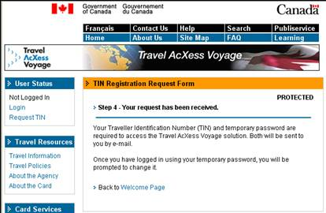

Figure 2.6a: TIN Registration Request Completion Page

Select Back to Welcome Page to proceed to the Welcome page.

If you were unable to find your name on the Name Selection page, you will be instructed to contact the Travel AcXess Support Desk to obtain a TIN and Temporary Password.

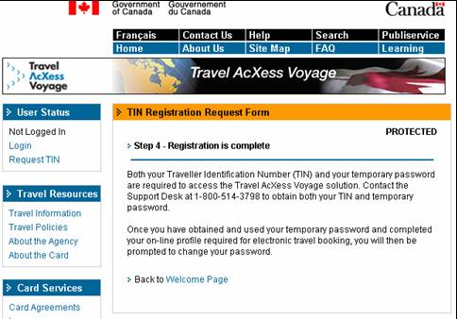

Figure 2.6b: TIN Registration Request Completion Page

Select Back to Welcome Page to proceed to the Welcome page.

Tip: 1. The Back to Welcome Page link should not be confused with the "Back" button
on the browser.

Figure 2.7: Portal Welcome Page

You have now returned to the portal Welcome page and will be able to log into the portal Home page to continue your new user set up with your TIN and Temporary Password once you receive them.

Completing the New User Setup

Once you have obtained your TIN, you must complete the New User Set-Up to begin using the portal. Voyage. This section outlines the process for setting up your traveller Profile. As before, you must begin by selecting your language.

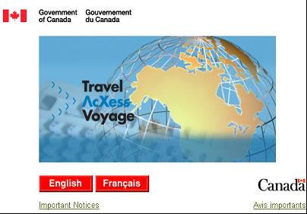

Figure 2.8: Portal Language Selection Page

► Accessing the Portal

1. Enter the following URL into the address bar of the browser:
http://travel-voyage.gc.ca;
2. Select English or Français;

The Welcome page is displayed.

Once you have selected your language you proceed to the Welcome page, which is shown below. Since you have a TIN and a Temporary Password, you are considered to be a returning traveller, so you will simply have to log into the portal to access to full features of the portal.

Figure 2.9: Portal Welcome Page

► Accessing the Portal (Cont’d.)

- Select Login on the left navigation bar.

The Login page is displayed. To log into the portal, you will need your TIN and your temporary password.
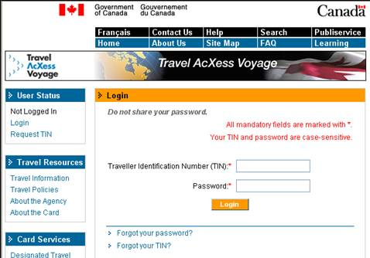

Figure 2.10: Login Page

► Logging In

- Enter a valid TIN and Temporary Password which you received either by e-mail or by calling the Travel AcXess Voyage Support desk;
- Select Login.

The Verify Secret Question and Answer page is displayed.

Tips: 1. Keep your Temporary Password available, but in a safe location. You
will need it again during the new user set up process.
2. After three consecutive, unsuccessful login attempts, you will be locked out of the
portal for five days (unless you contact the Travel AcXess Voyage Support Desk
for assistance)

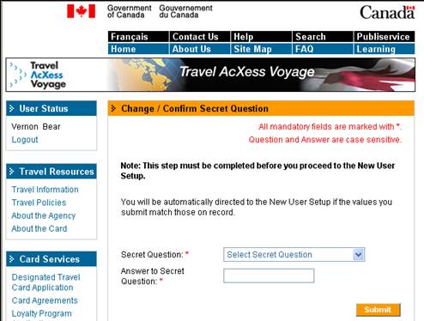

Figure 2.11: Secret Question and Answer Verification Page

► Verifying your Secret Question and Answer

You are required to verify your secret question and answer before entering the New User Setup as a means of ensuring that your TIN and temporary password were sent to the correct person.

- Select the Secret Question selected during the request TIN process
from the drop-down list;
- Enter the Answer to the Secret Question;
- Select Submit.

You will then proceed to the New User Setup page.
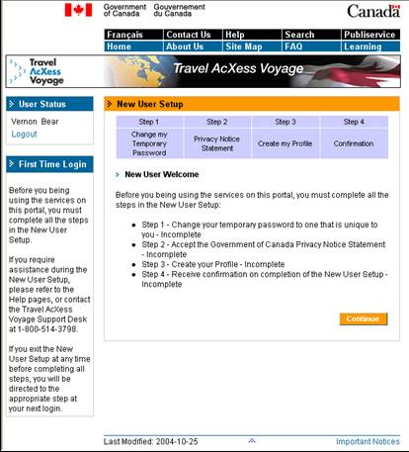

Figure 2.12: New User Setup Welcome Page

► Completing the New User Setup

- Read the information on the screen;
- Select Continue.

After selecting Continue, you will be able to begin the traveller set up process and complete your travel Profile. You will begin by changing you personal password. You will need your Temporary Password for this step.

Step 1: Change My Password

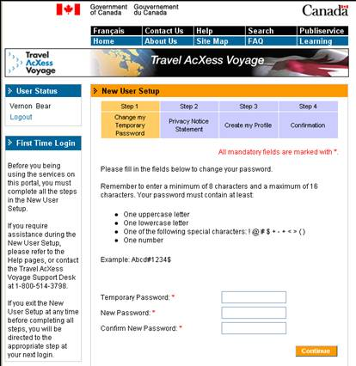
Figure 2.13: Change my Password Page

► Changing Password

- Enter Temporary Password;
- Enter and confirm a New Password;
- Select Continue.

The New Password Confirmation page is displayed.

Tips: 1. Select a password that is easy to remember, but would be difficult for others to
guess.
2. A password will have to include one of the following characters: !, @, #, $, +, -, =,
<, >, (, ).
3. A password must include both upper case and lower case letters and must be at
least 8 characters but not more then 16 characters.

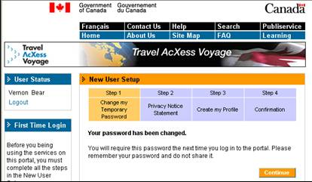

Figure 2.14: Change my Password Confirmation Page

► Changing Password (Cont’d.)

4. Select Continue.

The Privacy Notice Statement page is displayed.

Step 2: Viewing the Privacy Notice Statement

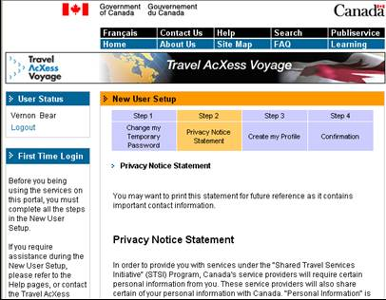

Figure 2.15: Privacy Notice Statement Page

As part of the New User Setup and before using the portal, you must accept the Government of Canada’s Privacy Notice Statement.

► Accepting the Privacy Notice Statement

- Review the terms of the Privacy Notice. If the terms are acceptable, select Accept & Continue.
Otherwise, select Decline.

If you select Accept & Continue, you are directed to the next step in the New User Setup -- creating your initial Profile. If you select Decline, you will be given the option to cancel and return to the Privacy Notice Statement. If you still want to decline, you will be logged out and directed to the Welcome Page.

Step 3: Create my Profile

Your Profile is a record of all the contact information, billing information, and travel preference required to efficiently book your travel. During the New User Setup, you are required to fill out an initial Profile with a number of mandatory fields in order to begin using the functions on the portal.

There are many more fields in the full Profile that will help to make your travel booking and management experience an easy one. You can return to complete your full Profile by selecting Profile/X.400 in the User Status portlet on the left navigation bar at any time after finishing the New User Setup.

New user Profile Detail Page

This form is the initial Profile which will collect some preliminary details.

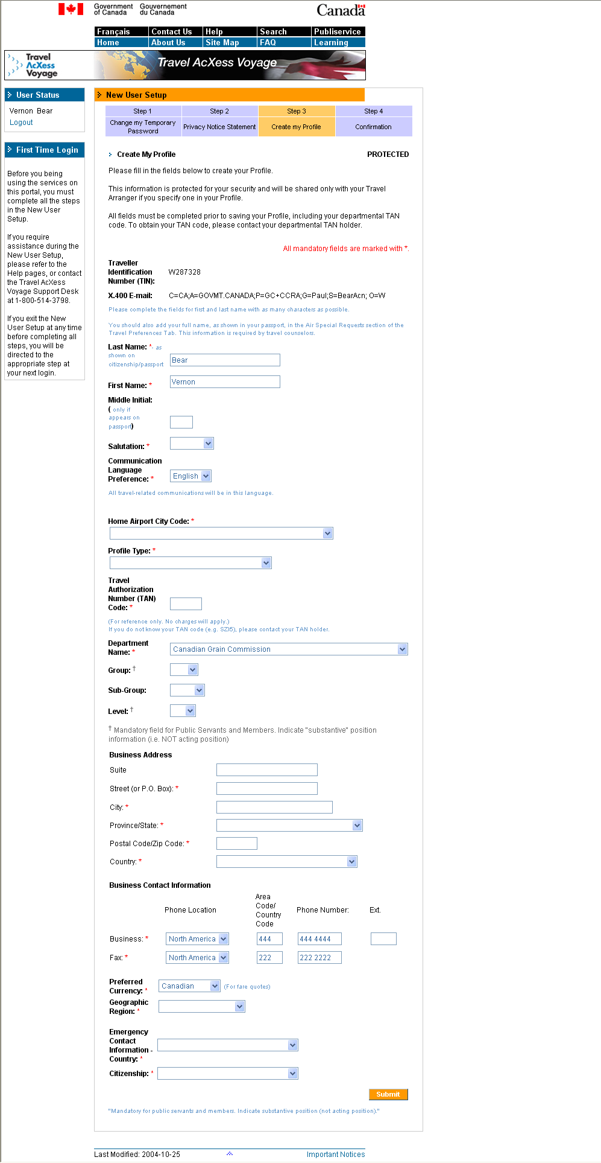

Figure 2.16a : Create My Profile Page

► Creating an Initial Profile

1. Enter a Last Name;
2. Enter a First Name;
3. Enter a Middle Initial;
4. Select a Salutation from the drop-down list;
5. Select Communication Language Preference from the drop-down list;
6. Select a Home Airport City Code from the drop-down list;
7. Select a Profile Type from the drop-down list;

Figure 2.16b: Create My Profile Page (Cont’d.)

► Creating an Initial Profile (Cont’d.)

8. Enter the applicable Travel Authorization Number Code;
9. Select a Department Name;
10. Select a Group from the drop-down list;
11. Select a Sub-group, if applicable from the drop-down list;
12. Select a Level from the drop-down list;
13. Enter a Business Address Suite;
14. Enter a Business Street Address;
15. Enter a Business City;
16. Select a Business Province/State from the drop-down list;
17. Enter a Business Postal Code/Zip Code;
18. Select a Business Country from the drop-down list;

Tips: 1. The Travel Authorization Number (TAN) Code is the prefix for the TAN
number. The TAN Code is dependent on your department. If you do not know
your TAN Code (e.g. SZI5), please contact your TAN holder.
2. The TAN code is a four character alphanumeric code tied to the organization
entity where the travel expenses are going to be invoiced.
3. You can enter city names that include numbers.
4. A Street Address field can include a ‘-‘ , ‘/’ and a ‘*’
5. The profile name field consists of the following elements: Salutation, First Name,
Middle Initial, and Last Name. The combination of these 4 can not exceed 40
characters: Salutation: 6 characters, First Name: 8 characters, Middle initial: 1
character (Required for passport and to identify users with same first & last
names), Last name: 25 characters.

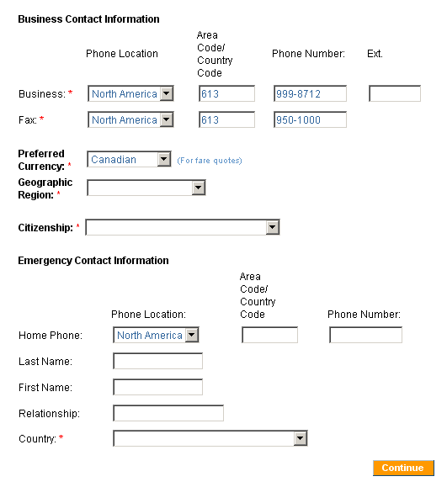
Figure 2.16c: Create My Profile Page (Cont’d.)

► Creating an Initial Profile (Cont’d.)

- Enter a Business phone number;
- Enter a Business Fax number;
- Select a Preferred country’s Currency from the drop-down list;
The preferred currency is the currency in which monetary amounts will be referred
to as in correspondence to the traveller.
- Select a Geographic Region from the drop-down list;
- Select your Citizenship from the drop-down list;
- Select the Home Phone Location from the drop-down list and enter the Area Code and Home Phone Number of an Emergency Contact;
- Enter the Last Name of an Emergency Contact;
- Enter the First Name of an Emergency Contact;
- Enter the Relationship you have with your Emergency Contact;
- Select the Country of an Emergency Contact from the drop-down list;
- Select Submit.

Tip: 1. Phone and fax numbers must include either a space or a ‘-‘

Step 4: Viewing the New User Set Up Confirmation Page
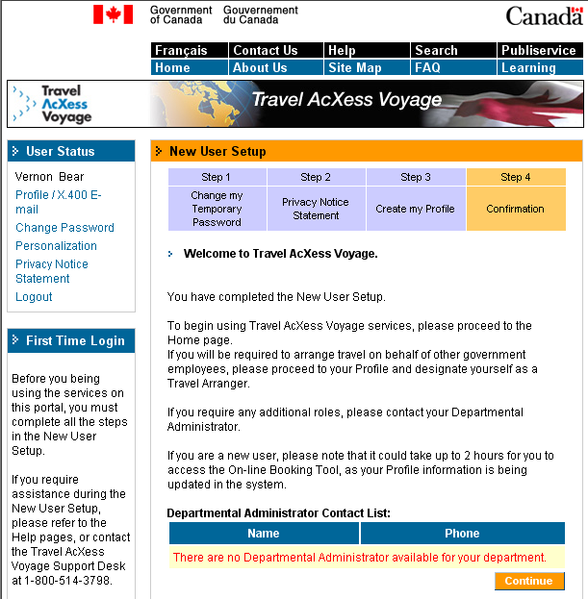

Figure 2.17: New User Setup Confirmation Page

► Completing the New user setup process

1. Select Continue to proceed to the main portal Home page.

Tip: 1. On Step 4 of the New User Setup process you will see a Departmental Administrator Contact List at the bottom of the page. Please take note of this information since this is the only time this contact list will appear.
2. Upon completion of your initial profile, please allow two hours for the information to be properly uploaded so you can access the On-line Booking Tool. Should you try to select the Book Travel link prior to that, you may receive an error message indicating that the system cannot find the resources requested.

3 Accessing the Portal as a Returning Traveller

Once you have completed the New User Setup process, you will be able to access the portal as a returning traveller. As a returning traveller, you will be able to complete a more detailed Profile, change your password and your X.400 E-mail address, and personalize your portal.

3.1 Entering the Portal

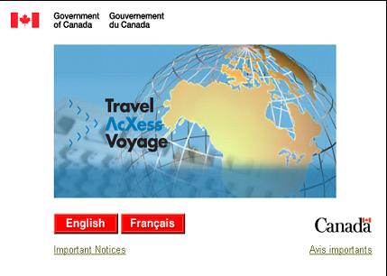

Figure 3.1: Portal Language Selection Page

► Accessing the Portal

1. Enter the following URL into the address bar of the browser:
http://travel-voyage.gc.ca;
2. Select English or Français;

This will take you to the Welcome page, displayed in the language of your choice.

Figure 3.2: Portal Welcome Page

► Logging in

- Select Login on the left navigation bar.

3.2 Logging In

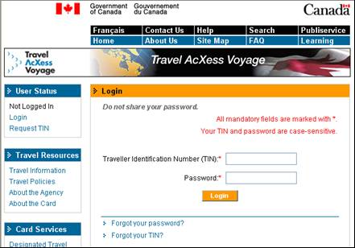

Figure 3.3: Login Page

► Logging In (Cont’d.)

- Enter a valid TIN and Password;
- Select Login.

Once you have logged in, you will proceed to the portal Home page. However, first we will examine two possible situations.

- Forgot your password
- Forgot your TIN

3.3 Forgotten Password

In the event that you have forgotten your Password, you can request a temporary replacement password from Travel AcXess Voyage, which you may then use to log in to the portal. Once you have logged in using the temporary password, you will be asked to change it.

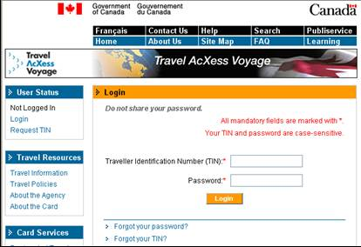

Figure 3.4: Login Page

► Requesting a Temporary Password

- Select Forgot your password? from the bottom of the screen.

The Forgot Password page is displayed.

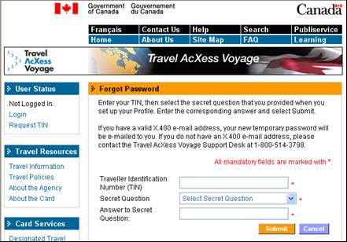

Figure 3.5: Forgot Password Page

► Requesting a Temporary Password (Cont’d.)

- Enter the applicable Traveller Identification Number;
- Select a previously chosen Secret Question;
- Enter the Answer to the Secret Question;
- Select Submit.

Tip: 1. The answer to the secret question is case-sensitive. Your answer must exactly match
the answer you entered during the Request TIN process.

A page confirming the receipt of your password request is displayed.

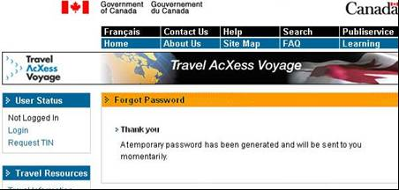

Figure 3.6: Forgot Password Confirmation Page for Travellers with an X.400 E-mail address

The confirmation page shows that a temporary password has been generated and that you will receive it by e-mail if you have an X.400 E-mail address. This process will only take a few minutes.

If you do not have an X.400 E-mail address, you must contact the Travel AcXess Voyage Support Desk by calling 1 800 514 3798 or selecting the Contact Us link

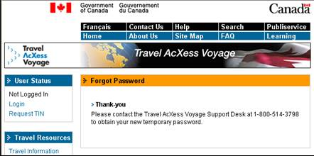

Figure 3.7: Forgot Password Confirmation Page for Travellers without an X.400 E-mail address

3.4 Recovering your Forgotten TIN

If you have forgotten your Traveller Identification Number, you can recover it by contacting the Travel AcXess Voyage Support Desk by calling 1 800 514 3798 or by selecting the Contact Us link.

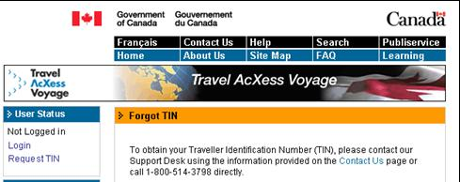

Figure 3.8: Forgot TIN Page

3.5 Managing your Profile and Portal

Once you have completed the New User Setup, you can maintain your Profile, change your Password, change your X.400 E-mail address and personalize your portal. The following chapter outlines the steps required to carry out those tasks.

3.5.1 Managing your Profile
Maintaining your Profile is important so that you can keep your personal information and travel preferences current. This information will enable Travel AcXess Voyage to locate you in an emergency, make booking payments and book travel according to your preferences.

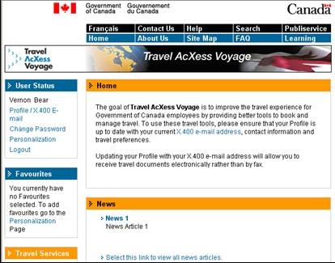

Figure 3.9: Portal Home Page

► Managing your Profile

1. Select Profile/X.400 E-mail from the left navigation bar.

The Profile/X.400 E-mail page is displayed.

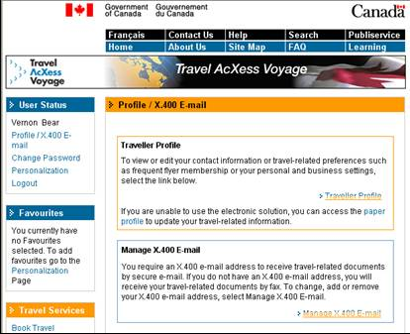

Figure 3.10: Profile/X.400 E-mail Page

► Managing your Profile (Cont’d.)

2. Select >Traveller Profile from within the Traveller Profile text box.

The Profile page is displayed.

Traveller Profile Detail Page - Personal

The Personal tab contains your personal and emergency contact information. This tab also contains your credit card, passport and visa information.

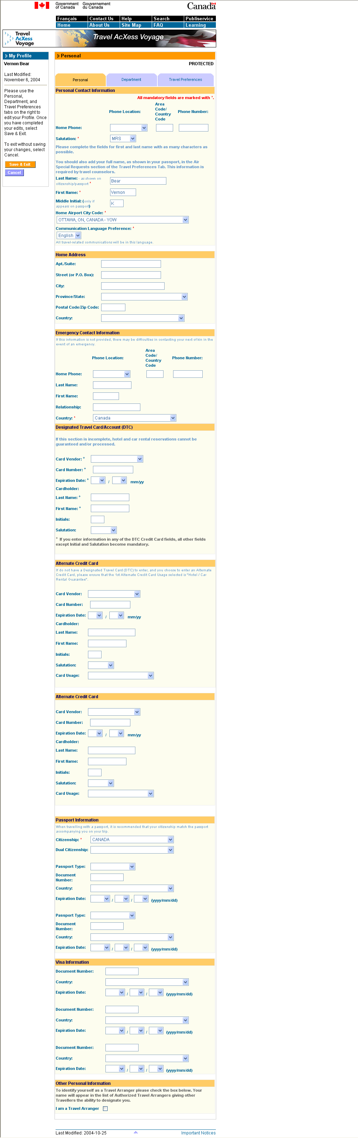

Figure 3.11a: Department Profile Page

► Completing the Traveller Profile Detail Page - Personal tab
Personal Contact Information

1. Enter a Home Phone number;
2. Select a Salutation;
3. Enter a Last Name;
4. Enter a First Name;
5. Enter a Middle Initial;
6. Select a Home Airport City Code from the drop-down list;
7. Select a Communication Language Preference from the drop-down list;
8. Scroll down to the next section;

Tips: 1. Check your Profile regularly to make sure that your details are current.
2. All fields marked with an asterisk are mandatory fields and must be completed.
Answering all other fields would help make your travel more convenient and
enjoyable.

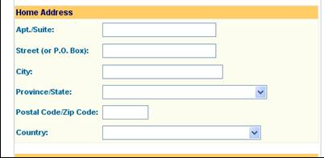

Figure 3.11b: Personal Profile Page (Cont’d.)

► Modifying the Traveller Profile Detail Page – Personal tab (Cont’d.)
Home Address

9. Enter a Home Suite Number;
10. Enter a Home Street name or PO Box number;
11. Enter a Home City;
12. Select a Home Province/State from the drop-down list;
13. Enter a Home Postal Code/ZIP Code;
14. Select a Home Country from the drop-down list;
15. Scroll down to the next section;

Tip: 1. Check your Profile regularly to make sure that your details are current.

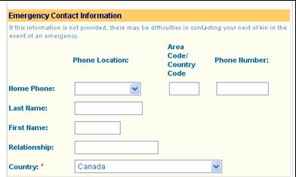

Figure 3.11c : Personal Profile Page (Cont’d.)

► Completing the Traveller Profile Detail Page – Personal tab (Cont’d.)
Emergency Contact Information

16. Select a Home Phone Location and enter a Home Phone Number (including the
country code – if required) for the Emergency Contact;
17. Enter the Last Name of the Emergency Contact;
18. Enter the First Name of the Emergency Contact;
19. Enter the Relationship with the Emergency Contact;
20. Select the home Country of the Emergency Contact from the drop-down list;
21. Scroll down to the next section;

Tip: 1. Check your Profile regularly to make sure that your details are current.

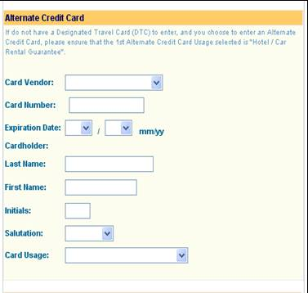

Figure 3.11d: Personal Profile Page (Cont’d.)

► Completing the Traveller Profile Detail Page – Personal tab (Cont’d.)
Alternate Credit Cards

22. Select a Credit Card Vendor from the drop-down list;
- Enter a Credit Card Number;
- Select a Credit Card Expiration Date from the drop-down list;
- Enter the Last Name of the Credit Card Holder;
- Enter the First Name of the Credit Card Holder;
- Enter the Initials of the Credit Card Holder;
- Select the Salutation of the Credit Card Holder from the drop-down list;
- Select the Credit Card Usage from the drop-down list;
- Scroll down to the next section;

Tips: 1. Information for a second alternate credit card can be added.
2. Check your Profile regularly to make sure that your details are current.
3. The information provided in the Alternate Credit Card sections if optional.

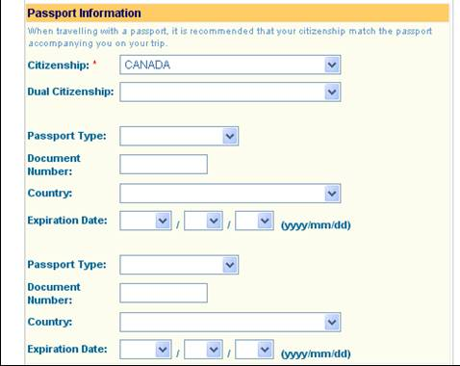

Figure 3.11e: Personal Profile Page (Cont’d.)

► Completing the Traveller Profile Detail Page – Personal tab (Cont’d.)
Passport Information

31. Select a country of Citizenship from the drop-down list;
32. Select a Dual Citizenship, if applicable, from the drop-down list ;
33. Select a Passport Type from the drop-down list;
34. Enter a Document Number;
35. Select the issuing Country of the Passport from the drop-down list;
36. Select the Expiration Date of the Passport from the drop-down lists;
37. Scroll down to the next section;

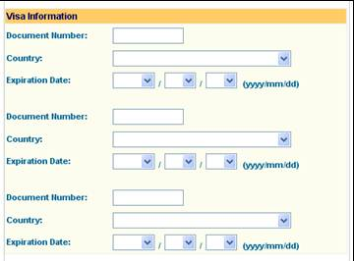

Figure 3.11f: Personal Profile Page (Cont’d.)

► Completing the Traveller Profile Detail Page – Personal tab (Cont’d.)
Visa Information

38. Enter the Document Number;
39. Select the issuing Country of the Visa from the drop-down list;
40. Select the Expiration Date of the Visa from the drop-down list;
41. Scroll down to the next section;

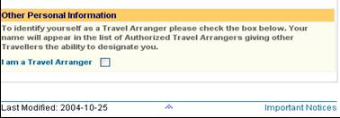

Figure 3.11g: Personal Profile Page (Cont’d.)

► Completing the Traveller Profile Detail Page – Personal tab (Cont’d.)
Visa Information

42. Check the Travel Arranger box if applicable;
43. Scroll back to the top of the page and select the Department tab.

Tips: 1. Check your Profile regularly to make sure that your details are current.
2. If you are a Travel Arranger, check the Travel Arranger box. Your name will
appear in a list of Authorized Travel Arrangers giving other travellers the
ability to designate you as their Travel Arranger.

Traveller Profile Detail Page – Department Information

This tab contains information on your department and your designated Travel Arrangers.

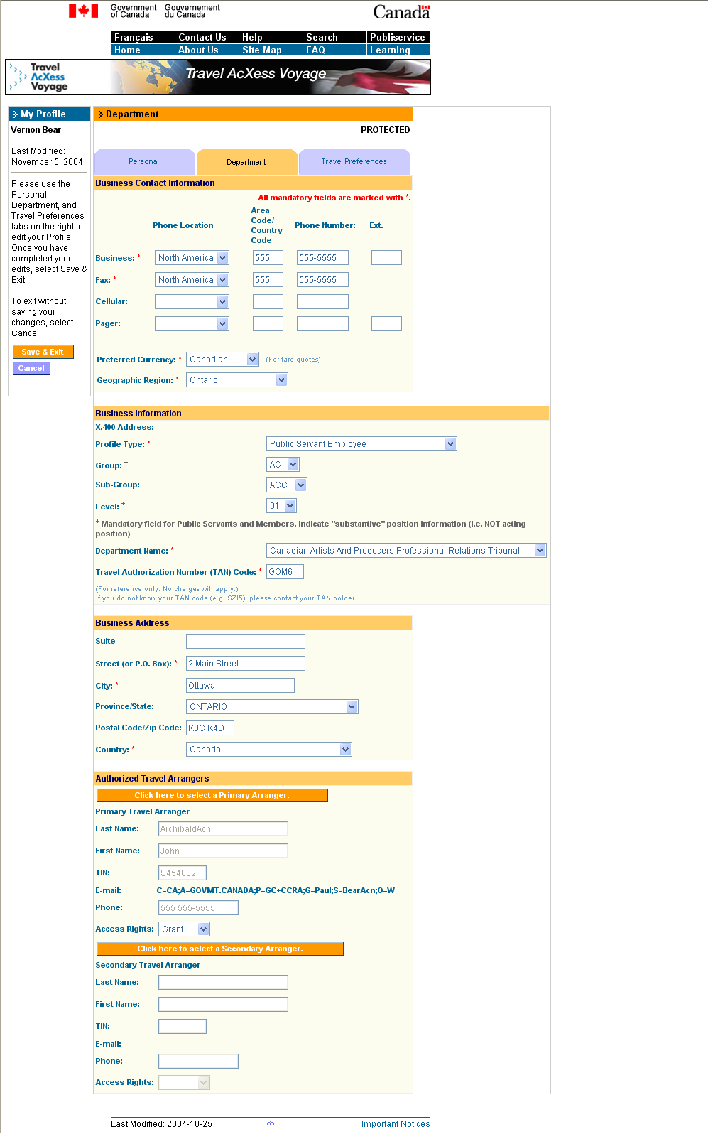
Figure 3.12a: Department Profile Page

► Completing the Traveller Profile Detail Page - Department tab
Business Contact Information

- Select a Business Phone Location and enter a Business Phone Number (including
the country code – if required);
2. Select a Home Fax Location and enter a Home Fax Number (including the
country code – if required);
3. Select a Cellular Phone Location and enter a Cellular Phone Number (including the
country code – if required);
4. Select a Pager Location and enter a Pager Number (including the
country code – if required);
5. Select a Preferred Currency from the drop-down list;
6. Select a Geographic Region from the drop-down list;
7. Scroll down to the next section;

Tips: 1. Check your Profile regularly to make sure that your details are current.
2. All fields marked with an asterisk are mandatory fields and must be completed.
Answering all others would be helpful.

Figure 3.12b: Department Profile Page (Cont’d.)

► Completing the Traveller Profile Detail Page - Department tab (Cont’d.)
Business Information & Business Address

8. Select a Profile Type from the drop-down list;
9. Select a Group from the drop-down list;
10. Select a Subgroup from the drop-down list;
11. Select a Level from the drop-down list;
12. Select a Department Name from the drop-down list;
13. Enter a Travel Authorization Number Code;
13. Enter a Business Suite Number;
14. Enter the Business Street name or PO Box number;
15. Enter the Business City;
16. Select the Business Province/State from the drop-down list;
17. Enter the Business Postal Code/Zip Code;
18. Select the Business Country from the drop-down list;
19. Scroll down to the next section;

Tip: 1. Check your Profile regularly to make sure that your details are current.

If you intend to have a Travel Arranger book travel on your behalf, you must select one.

Figure 3.12c: Department Profile Page (Cont’d.)

► Completing the Traveller Profile Detail Page - Department tab (Cont’d.)
Authorized Travel Arrangers

20. Select Click here to select a Primary Arranger;

The Travel Arranger Search page is displayed.

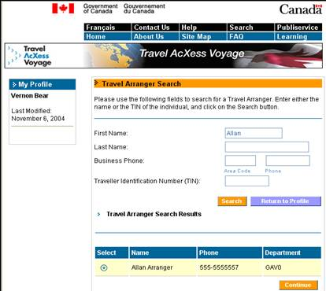

Figure 3.13: Travel Arranger Search Page

► Searching for Authorized Travel Arrangers

1. Enter the First Name of the Travel Arranger;
2. Enter the Last Name;
3. Enter the Business Phone Number of the Travel Arranger; or
4. Enter a Travel Arranger’s TIN;
5. Select Search.

The results of the Travel Arranger search are displayed at the bottom of the page.

► Selecting an Authorized Travel Arranger

1. Select the suitable Travel Arranger;
2. Select Continue.

Tip: 1. Try to complete as many fields as possible to narrow down the list of Travel
Arrangers that you wish to arrange your travel. Alternatively, select Search to
obtain a complete list of available Travel Arrangers.

You will be returned to the Profile page. Details for your Travel Arranger are automatically entered in the fields on the Profile.

Figure 3.12d : Department Profile Page (Cont’d.)

► Completing the Traveller Profile Detail Page - Department tab (Cont’d.)
Authorized Travel Arrangers

3. Select the primary Travel Arranger’s Access Rights from the drop-down list; and
4. Scroll back to the top of the page and select the Travel Preferences tab.

When selecting the access rights for a Travel Arranger, you may select from three options:

- Grant - Allows your Travel Arranger to view and edit your Profile as well as to book travel
on your behalf using the OBT
- Deny - Allows your Travel Arranger to book travel on your behalf using the OBT, but to view
your Profile
3. Remove - Deletes the Travel Arranger from your Profile

An Authorized Travel Arranger is a Government of Canada employee authorized to make travel arrangements on your behalf.
A Primary Travel Arranger will be making bookings on your behalf.
A Secondary Travel Arranger can also make bookings on your behalf. You can request that either the Primary or Secondary Travel Arranger make arrangements for you. The Primary Travel Arranger does not take precedence over the Secondary Travel Arranger.

Tip: 1. Check your Profile regularly to make sure that your details are current.

Traveller Profile Detail Page – Travel Preferences

This tab contains your personal travel preferences.

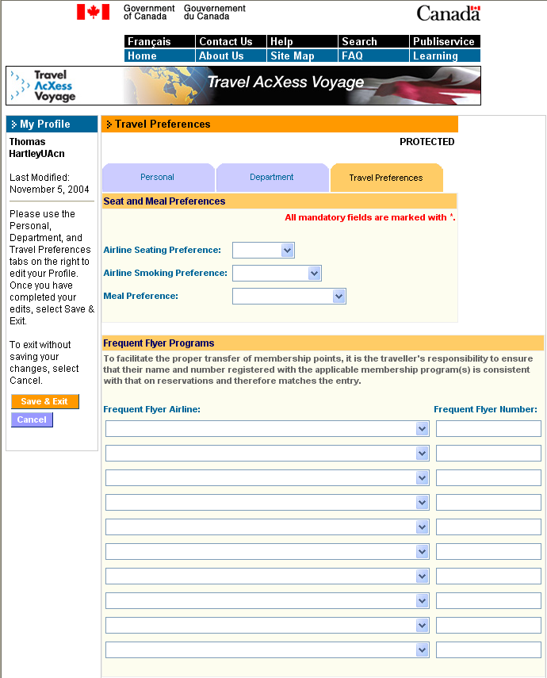

Figure 3.14a: Travel Preferences Profile Page

► Completing the Traveller Profile Detail Page – Travel Preferences tab
Seat & Meal Preferences and Frequent Flyer Programs

1. Select an Airline Seating Preference from the drop-down list;
2. Select an Airline Smoking Preference from the drop-down list;
3. Select a Meal Preference from the drop-down list;
4. Enter any applicable airline Frequent Flyer Programs;
5. Scroll down to the next section;

Tip: 1. Check your Profile regularly to make sure that your details are current.

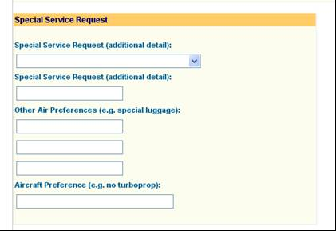
Figure 3.14b: Travel Preferences Profile Page (Cont’d.)

► Completing the Traveller Profile Detail Page – Travel Preferences tab
(Cont’d.) Special Service Requests

6. Select any Special Service Requests from the drop-down list;
7. Enter any Special Service Requests;
8. Enter any Other Air Preferences;
9. Enter an Aircraft Preference;
10. Scroll down to the next section;

Tips: 1. None of the information on this form is mandatory.
2. Check your Profile regularly to make sure that your details are current

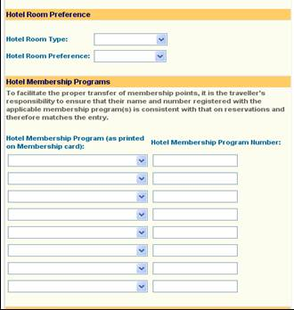

Figure 3.14c: Travel Preferences Profile Page (Cont’d.)

► Completing the Traveller Profile Detail Page – Travel Preferences tab
(Cont’d.) Hotel Room Preference & Hotel Membership Programs

11. Select a Hotel Room Type from the drop-down list;
12. Select a Hotel Room Preference from the drop-down list;
13. Enter any Hotel Membership Programs;
14. Scroll down to the next section;

Tip: 1. Check your Profile regularly to make sure that your details are current.

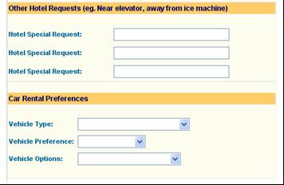

Figure 3.14d : Travel Preferences Profile Page (Cont’d.)

► Completing the Traveller Profile Detail Page – Travel Preferences tab
(Cont’d.) Other Hotel Requests & Vehicle Preferences

15. Enter any Hotel Special Requests;
16. Select a Vehicle Type from the drop-down list;
17. Select a Vehicle Preference from the drop-down list;
18. Select Vehicle Options from the drop-down list;
19. Scroll down to the next section;

Tips: 1. A Hotel Special Request could include a request for a ground floor room.
2. A Vehicle Option could include a child/toddler seat.
3. Check your Profile regularly to make sure that your details are current.

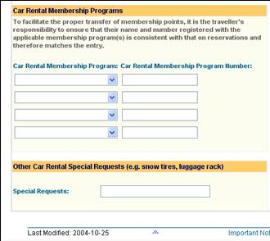

Figure 3.14e: Travel Preferences Profile Page (Cont’d.)

► Completing the Traveller Profile Detail Page – Travel Preferences tab
(Cont’d.) Car Membership Programs & Other Car Rental Special Requests

- Select a Car Rental Membership Program from the drop-down list and enter any
Car Rental Membership Program Numbers;
21. Enter any other Car Rental Special Requests;
22. Scroll to the top of the page and Select Save & Exit;

Tip: 1. A Special Request could include a request for vehicles with automatic transmission.

A confirmation page is displayed.

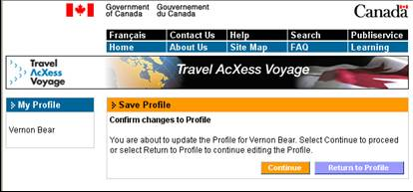

Figure 3.15: Traveller Profile Confirmation Page

► Confirming Changes made to the Traveller Profile Detail Page

- Select Continue.

You will then proceed to the following page which will indicate that the changes that you have made to your Profile have been submitted to Travel AcXess Voyage.

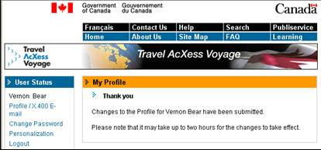

Figure 3.16: Traveller Profile Submission Page

3.5.2 Changing your Password

If you would like to change your password for security or other reasons, you can make the change from the Home page.

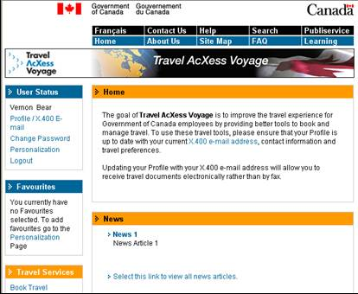

Figure 3.17: Home Page

► Changing your Password

1. Select Change Password in the left navigation bar

The Change Password page is displayed.

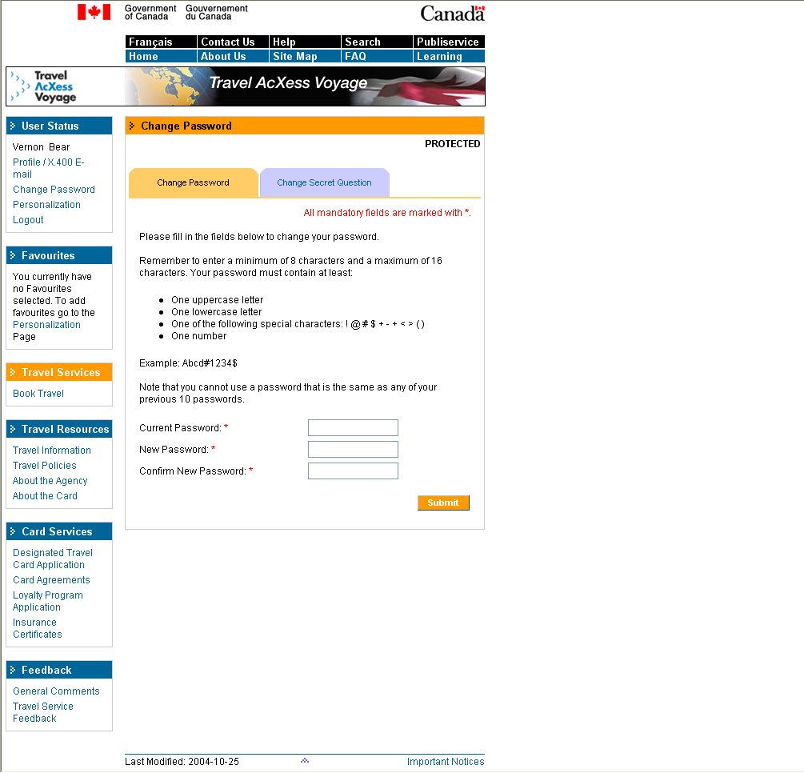
Figure 3.18: Change Password Page

► Changing your Password (Cont’d.)

2. Enter the Original Password;
3. Enter a New Password;
4. Confirm the New Password;
5. Select Submit.

Tips: 1. You will be required to change your password every 180 days as a
security measure.
2. Select a password that is easy to remember but difficult for others to guess.
3. Your password must include at least one of the following characters :!, @, #, $, +, -,
=, <, >, (, )
4. Your password must also include at least one uppercase, one lowercase case
letter, and one number.
5. Your password must range from at least 8 characters to a maximum of 16
characters.

A page is displayed to confirm your password change.

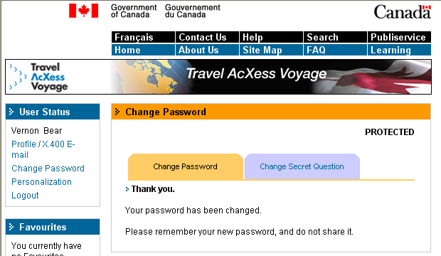

Figure 3.19: Change Password Confirmation Page

3.5.3 Changing Your Secret Question

If you would like to change your secret question for security or other reasons, you can make the change from the Home page.

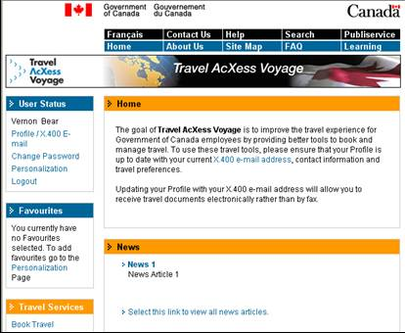
Figure 3.20: Home Page

► Changing your Secret Question

1. Select Change Password in the left navigation bar

The Change Password page is displayed.

Figure 3.21: Change Password/Change Secret Question Page

► Changing your Secret Question (Cont’d.)

2. Select the Change Secret Question tab at the top of the page.

The Change Secret Question page is displayed.

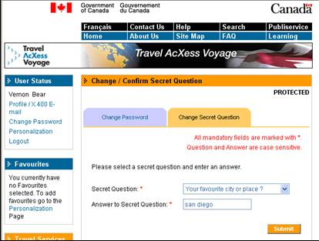

Figure 3.22: Change Secret Question Page

► Changing your Secret Question (Cont’d.)

3. Select a new Secret Question from the drop-down list;
4. Enter an Answer to the Secret Question;
5. Select Submit.

Tip: 1. The answer to your secret question is case-sensitive.

A page is displayed confirming the change to your Secret Question/Answer combination.

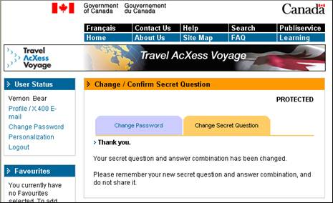
Figure 3.23: Change Secret Question Confirmation Page

3.5.4 Adding/Changing and Removing your X.400 E-mail address

Using the portal, you can:

- Add an X.400 E-mail address to your Profile if one is not currently listed
- Change the X.400 E-mail address currently listed in your Profile
- Remove the current X.400 E-mail address from your Profile

Each of these procedures will be outlined below.

Note: See Determining your X.400 Status section for an explanation of X.400 E-mail addresses.

Adding/Changing an X.400 E-mail address

If you do not have an X.400 E-mail address, you can add one to your Profile.

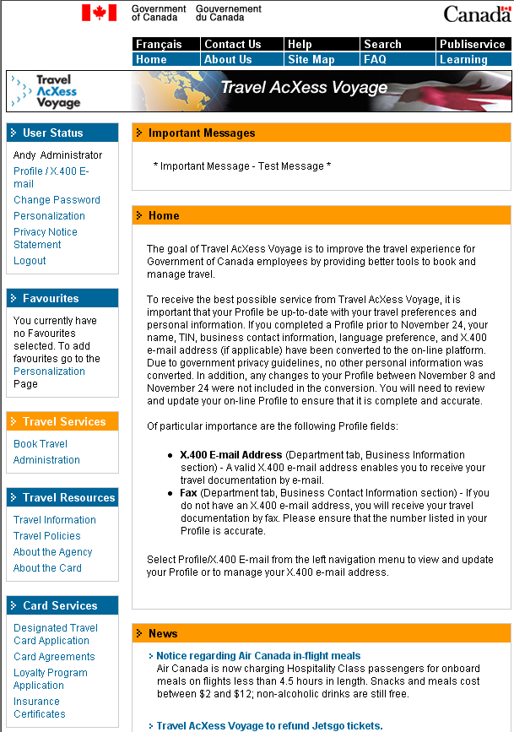
Figure 3.24: Home Page

► Adding/Changing an X.400 E-mail address to your Profile

- Select Profile/X.400 E-mail on the left navigation bar of the portal Home
page.

The Profile/X.400 E-mail page is displayed.

Figure 3.25: Profile Page

► Adding / Changing an X.400 E-Mail Address to your Profile (Cont’d.)

- Select >Manage X.400 E-mail from within the Manage X.400 E-mail text box in the centre of the Profile page.

The Manage X.400 E-mail address page is displayed.

The first step is to determine which X.400 E-mail address you possess. On this page you will be asked
for your first and last name as well as your business phone number.

If you already have an X.400 E-mail address, your address will appear at the top of the following page.

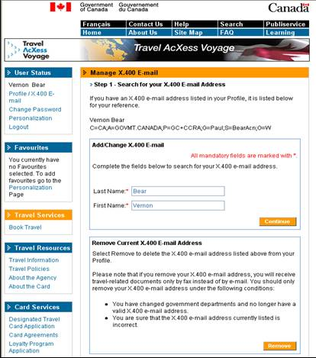

Figure 3.26: Add X.400 E-mail address Page

► Adding / Changing an X.400 E-mail Address to your Profile (Cont’d.)

- Enter a Last Name;
- Enter a First Name;
- Select Continue.

A list of names based on your search criteria will be generated on the following Web page. This list may contain the names of people with the same name as yours. Together with the information provided on the list, you should be able to recognize and select your name. If you are unable to find your name you will be directed to contact the Travel AcXess Voyage Help Desk.

Tip: 1. The Last Name field is pre-populated based upon the name attached to your travel
documents, so if the name you used to request TIN is different from the name in
your profile, the last name pre-populated here may not allow you to find your X.400
E-mail. You may have to modify the name to match your name used for business.

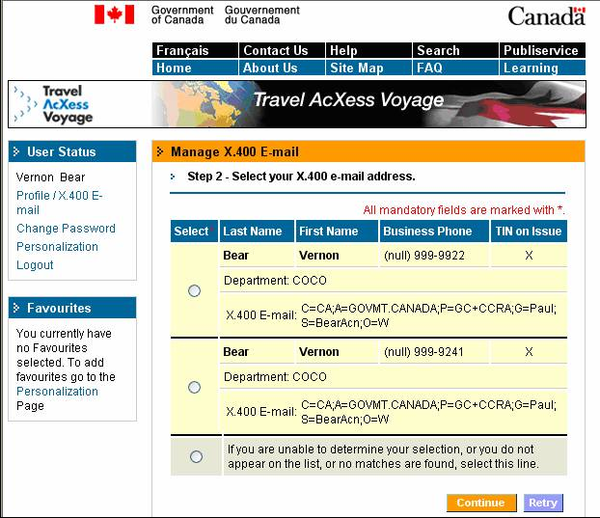

Figure 3.27: Add X.400 E-mail address Name Selection Page

► Adding / Changing an X.400 E-mail Address to your Profile (Cont’d.)

- Select the applicable name;
- Select Continue, if the applicable name appears, otherwise select the ‘If you are unable to….’ box and select Continue;

Your Profile is updated with the X.400 E-mail address you selected, and a confirmation page is displayed. Your travel-related documentation will now be sent to the new X.400 E-mail address.

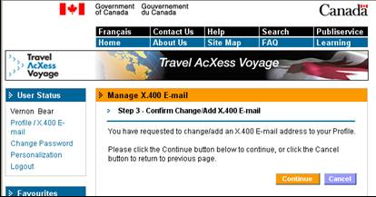

Figure 3.28: Add X.400 E-mail address Confirmation Page

► Adding / Changing an X.400 E-Mail Address to your Profile (Cont’d.) –
Confirmation

- Select Continue.

You will be directed to the Acceptance page.

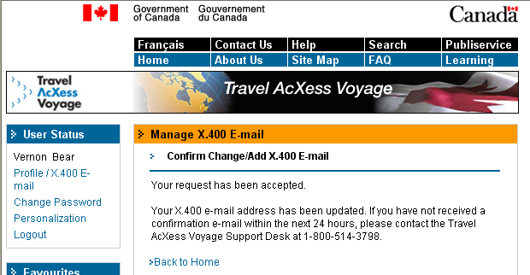

Figure 3.29: Add X.400 E-mail address Acceptance Page

If however no names matching your search are found, the following screen will appear:

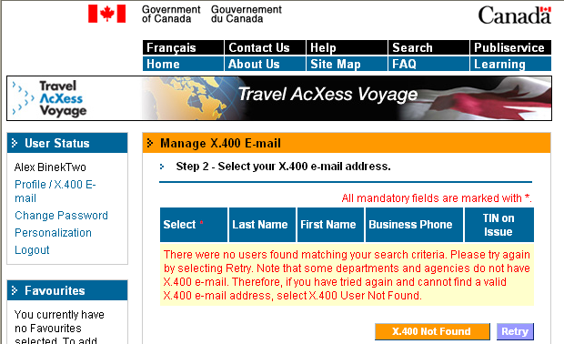

Figure 3.30: Add X.400 E-mail address no Users Found

► Adding / Changing an X.400 E-mail Address to your Profile (Cont’d) -
If your name does not appear

- Select X.400 Not Found otherwise Select Retry.

If you select the X.400 Not Found button or if you selected the ‘If you were unable to…’ box previously, you will be directed to contact the Travel AcXess Voyage Support Desk as shown in the screenshot immediately below.

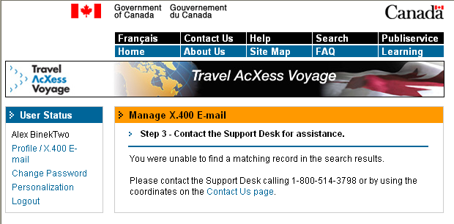

Figure 3.31: Contact Help Desk

2. Select Contact Us to find out how to contact the Travel AcXess Voyage
Technical Support Desk.

Removing your X.400 E-mail address

If you have an X.400 E-mail address listed in your Profile, you can remove it.

Figure 3.32: Home Page

► Removing an X.400 E-mail address from your Profile

- Select Profile/X.400 E-mail on the portal Home page.

The Profile/X.400 E-mail page is displayed.

Figure 3.33: Profile Page

► Removing an X.400 E-mail address from your Profile(Cont’d.)

- Select >Manage X.400 E-mail in the centre of the portal
Home page.

The Manage X.400 E-mail Address page is displayed.

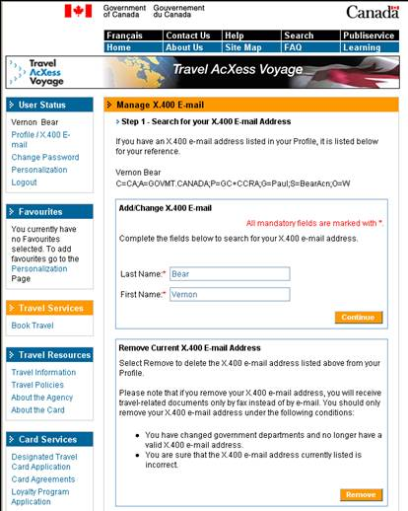

Figure 3.34: Changing X.400 E-mail address Page

► Removing an X.400 E-mail address from your Profile (Cont’d.)

3. Select Remove.

A confirmation page is displayed.

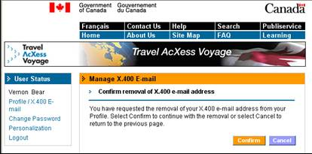

Figure 3.35: Confirmation of X.400 E-mail address Removal Page

► Confirming the Removal of an X.400 E-mail address

1. Select Confirm.

A page confirming your request is then displayed and you can select to go back to the Home page at that point.

Tip: 1. The removal of an X.400 E-mail address cannot be undone.

3.5.5 Personalizing your Portal

The personalization page allows you to personalize the portal by adding or removing links to your Favourites list in the left navigation bar. You can access the Personalization page from the Home page.

Figure 3.36: Home Page

► Entering the Personalization Page

1. Select Personalization in the left navigation toolbar.

The Personalization page is displayed.

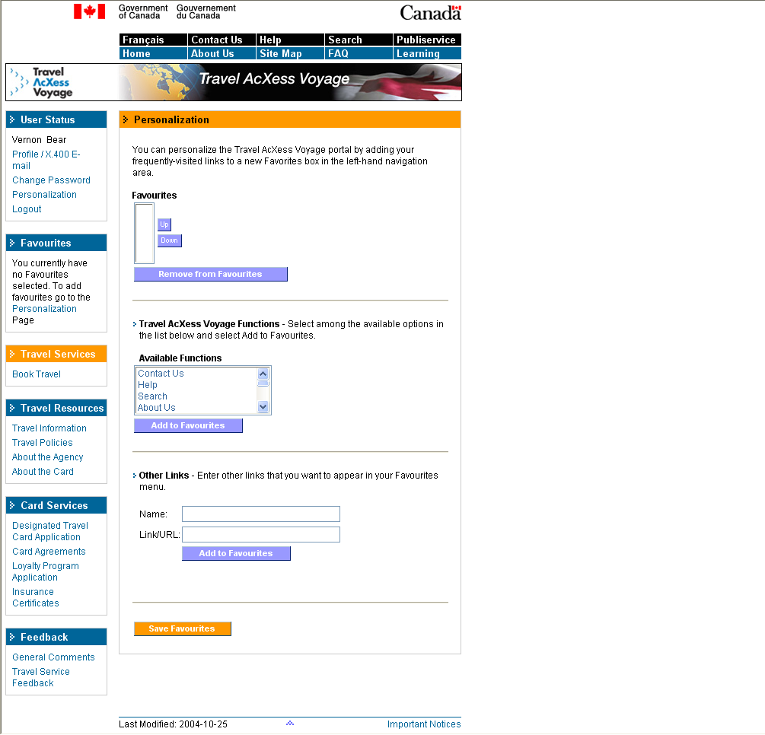

Figure 3.37: Personalization Page

► Personalizing your Portal

To add a favourite link:

- Select a desired portal function link from Available Functions to make it a favourite link;
- Select Add to Favourites;
- Select Save Favourites.

The new link is added to your Favourites portlet in the left navigation bar.

To remove a favourite link:

- Select the link from Favourites;
- Select Remove from Favourites.
- Select Save Favourites.

The new link is removed from your Favourites portlet in the left navigation bar.

To add non-portal links to your list of Favourites:

- Type in a name to be assigned to a favourite link;
- Enter the URL (Web address) for the link;
- Select Add to Favourites.
- Select Save Favourites.

The new link is added to your Favourites portlet in the left navigation bar.
Once you have finished adding favourites, select Home on the page header to return to the portal Home page.

4 Accessing the Portal as a Travel Arranger

Once you have completed the New User Setup process and been assigned the Travel Arranger role by your departmental portal administrator, you can book and manage travel on behalf of any Government travellers. Travellers for whom you wish to book travel must designate you as their Travel Arranger by completing the applicable fields in their Profile. This process is shown in section 3.4.1

4.1 Entering the Portal

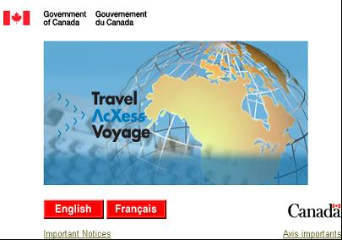

Figure 4.1: Portal Language Selection Page

► Accessing the Portal

1. Enter the following URL into the address bar of the browser:
http://travel-voyage.gc.ca;
2. Select English or Français;

You will proceed to the Welcome Page.

Figure 4.2: Portal Welcome Page

► Selecting the Login link on the Welcome Page

- Select Login on the left navigation bar.

4.2 Logging In

Figure 4.3: Portal Login Page

► Logging In

1. Enter a valid TIN and Password;
- Select Login.

The Travel Arranger’s portal Home page is displayed.

4.3 Managing your Traveller’s Profiles

As a Travel Arranger, your Home page is very similar to the traveller’s Home page with the exception that you will see a link to Manage Traveller’s Profiles in the Travel Services portlet on the left navigation bar.

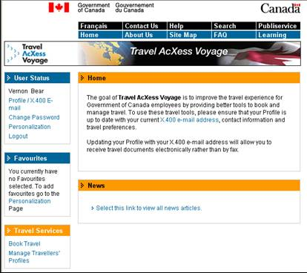

Figure 4.4: Portal Home Page

► Managing Your Travellers’ Profiles

1. Select Manage Traveller’s Profiles in the Travel Services portlet on
the left navigation bar.

A table is displayed listing the travellers who have granted you access to their Profiles.

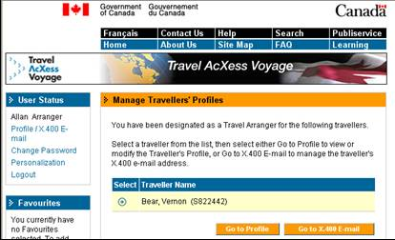

Figure 4.5: Travel Arranger Profile Selection Page

► Accessing a Traveller Profile

1. Select the Profile is to be accessed;
2. Select Go to Profile.

The Profile page is displayed for the traveller you selected. The traveller’s name is listed in the User Status portlet on the left navigation bar. The list of names returned are linked to the name the traveler entered in their profile (as it appears on their passport/citizenship). If you can not locate the name of the traveler you are looking for, you may want to ensure the traveler is not listed under another name in their profile (i.e., their maiden name).

Once you access the traveller’s Profile, you will be able to make changes to it. Instructions for changing Profile fields are listed in Section 3.5.1

► Modifying a Traveller’s X.400 E-mail Address:

1. Select the Profile is to be accessed;
2. Select Go to X.400 E-mail.

You will be directed to the traveller’s Manage X.400 E-mail Address page. The name of the traveller is shown in the navigation bar of the web page. Instructions for changing X.400 E-mail contents are dealt with in Section 3.5.4

Examples for both traveller’s Profile and X.400 pages as seen by a Travel Arranger are shown below.

Tip: 1. If you have been given access to a traveller’s Profile incorrectly, contact the
traveller via the business phone number given in their Profile and ask them to
remove your name from their Travel Arranger section of their Profile.
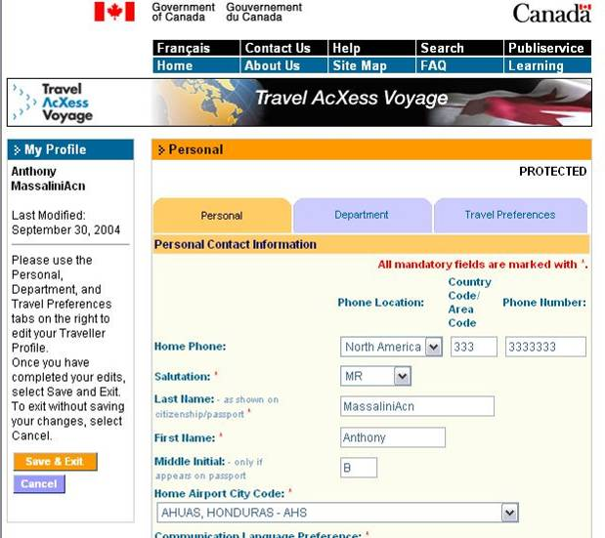

Figure 4.6: Example of a Traveller’s Profile Page

The name of the traveller appears in the top left of the Web page under the > My Profile heading.

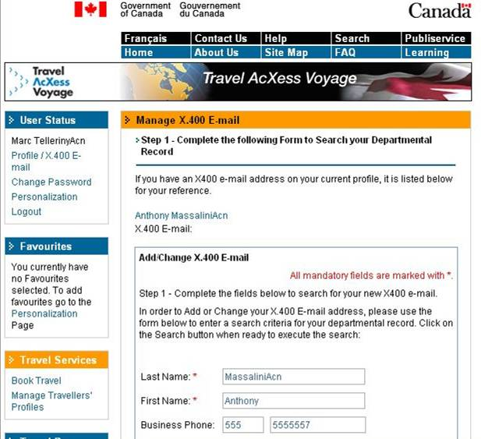

Figure 4.7: Example of a Traveller’s X.400 E-mail Page

The name of the traveller appears in the top left of the Web page under the > User Status heading.

