This job aid provides the steps on how to research and book a hotel in the On-line Booking Tool (OBT).

Procedure |  | Overview and Steps |  |  | Important Notes
1. Accessing the OBT Book Travel page  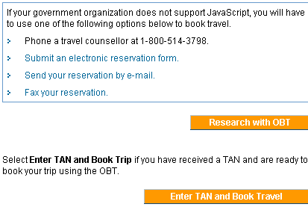  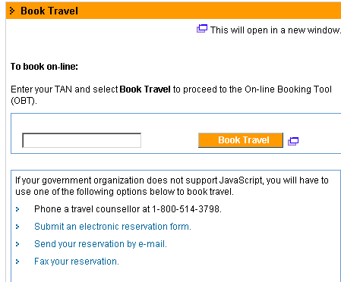 |  | To access the OBT, login to the portal and then indicate if you are researching a trip only or researching and booking a trip.  Logging into the Portal  1.1 Access the portal at http://travel-voyage.gc.ca.  1.2 To login to the portal, click the Login link from the portal page.  1.3 Enter your TIN and password.  1.4 Click Login. The Travel AcXess Voyage portal page appears.  Researching a Trip Only  1.5 Select Plan My Trip.  1.6 Click Research with OBT.  1.7 Click Continue. The OBT Research page will appear.  OR  Researching and Booking the Trip  1.5 Select Book My Trip under the Travel Services header.  1.6 Enter your TAN number on the Book Travel page.  1.7 Click Book Travel. | 1.5 If you are a travel arranger, and you plan a trip for yourself, select Plan My Trip. To perform any action on behalf of a traveler, you must select Manage Travellers.
2. Selecting trip requirements  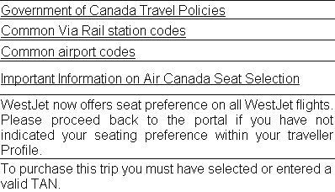  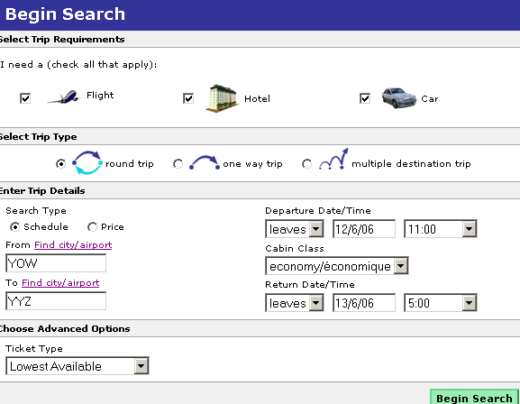 |  | (You will perform the initial step to search for a flight, hotel and car. The Flight, Hotel and Car checkboxes are selected by default). |  |  | It is not recommended to use the OBT to only book a hotel. To book a hotel only, contact the Travel AcXess Voyage counselor directly because the transaction fee will be lower.  It is recommended to print out the common airport and Via Rail station codes.  Job aids for researching and booking a flight and car are located at: http://stsi.gc.ca
2.1 Click Begin Search.
(You would now conduct research for the flight).

3. Searching for a hotel using the Government of Canada Accommodation and Car rental Directory (ACRD)  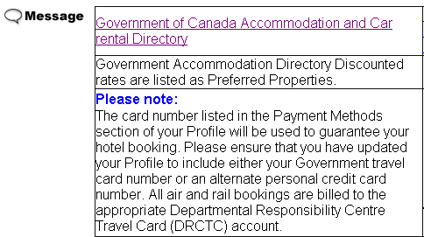 |  | (The Hotel Search page will appear after performing your search for the flight).  3.1 Click Government of Canada Accommodation and Car Rental Directory (ACRD) at the top of the Hotel Search page. |  |  | Messages at the top of the screen display information relevant to the search conducted.  The ACRD identifies GC preferred hotels, room type and GC approved room rates to look for in the online booking tool. The ACRD displays the hotels beginning with the lowest rates first.
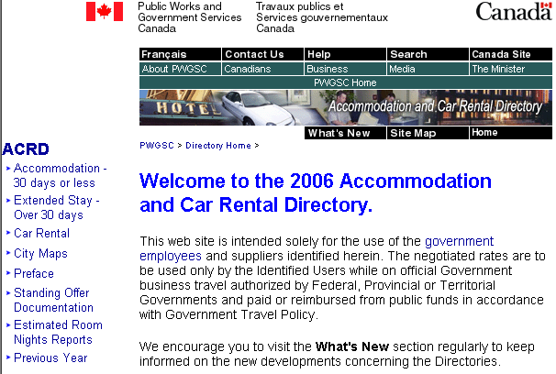 |  | 3.2 From the ACRD, select Accommodation-30 days or less. The Accommodation Search page appears.
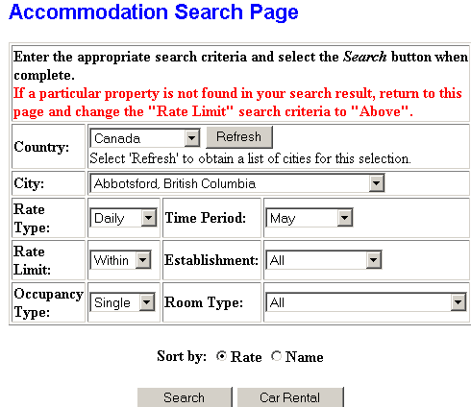 |  | 3.3 From the Accommodation Search Page, enter the appropriate search criteria.  3.4 Click Search when complete.
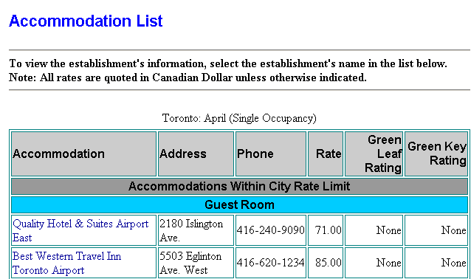 |  | From the Accommodation List, you can select Accommodation links to get details about the hotel.  3.5 You may print the Accommodation list of hotels agencies and rates.  OR  3.6 Close or minimize the ACRD window. If you minimize the ACRD window, you can refer back to it on an as needed basis.
4. Searching for a Hotel: Check In/Out Dates  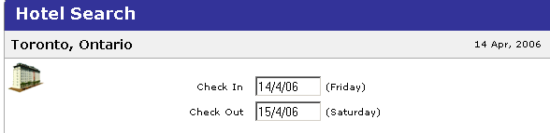 |  | (On the Hotel Search page, you will see the Check In and Check Out date fields are pre-populated with data entered from the Trip Details page. You can modify the dates if required). |  |  | Be aware that if the flight arrives after midnight, the check in date defaults to the next day. Make sure to change the check-in date to the flight departure date.
5. Searching for a Hotel: Type of Search  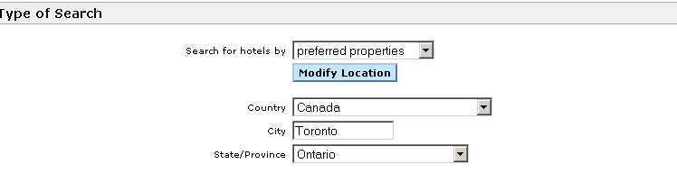 |  | (You can look for hotels using a search option such as preferred properties).  5.1 Click Search for hotels by drop down menu to view the search options.  5.2 Select the appropriate search option. |  |  | Search Options  It is recommended to use the Preferred Properties search option because it displays hotels listed in the ACRD (i.e., GC preferred hotels, room type and GC approved room rates). By default, the hotels that come up first in OBT are the ones closest to the airport.  If you use a search option, such as Downtown City Location, you can select a specific hotel chain or hotel.  It is not recommended to use Reference Point as a search option. The only point you can reference for Canadian destinations are hotels closest to the airport.  When to use the Modify option  Modify the search location if you intend on staying at a hotel for the entire trip that is not located in the same place as your flight destination (e.g., you arrive in Halifax, but you want to stay in New Glasgow). You will need to click Update, once you have modified the hotel location.
6. Searching for a Hotel using the Preferred Properties option  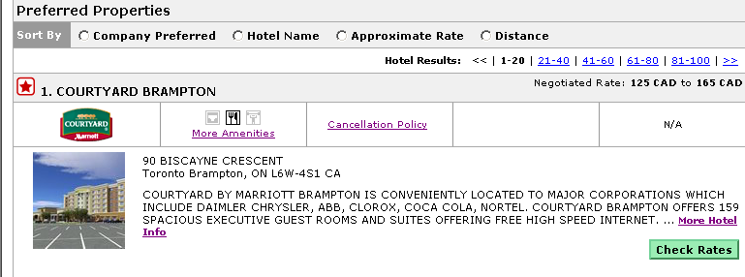 |  | (Once you locate a hotel you are interested in, you may click More Hotel Info for information about the hotel facilities etc. You should check the Cancellation policy for the hotel).  6.1 Select a hotel and click Check Rates. |  |  | Hotel Rates  Government preferred properties are identified by a red star. Compare the ACRD hotel rates to the OBT hotel rates to ensure you are getting the government-approved rate.  Hotel rates range from the lowest (guest room) to the highest (business class room).  The hotel cannot be booked  When checking a hotel rate, a page may appear indicating that the selected hotel cannot be booked at this time. You will be given three options.  If the following option is selected:  "Add this hotel to my itinerary and allow a travel agent to book it for me"  a counselor- assisted fee may be charged and you may be booked in a different room type (e.g., business class) at a higher cost.
7. Searching for a hotel: Select Room  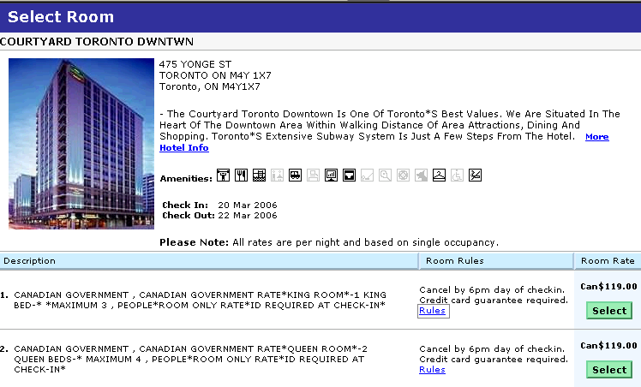  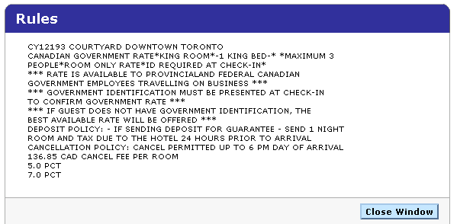 | (Check the hotel rules when you search for a room).  7.1 Click Rules to check the policies of the hotel.  7.2 Click Close Window.  7.3 Select a room type with a GC room rate. |  |  | Rules  Rules listed under the hotel may be different from rules listed in the ACRD. The government terms and conditions apply when you book a government preferred hotel at the approved rates.  The ACRD policy for the cancellation time is 4:00 pm. Deposits for the hotel are not required.  Hotel Description  Look for a room that denotes a Canadian Government hotel (GC code if applicable).  Room rate  If the room rate shown in the OBT does not match the rate shown in the ACRD, you may book the room and contact TAV (choose the option "for assistance with existing reservations done on OBT"), to ensure you get the government rate.  Rates are based on single occupancy.  Going on a business trip with your partner  If you call the TAV counselor to change the room from single occupancy to something else (e.g, double occupancy), a counsellor-assisted fee will be charged.
8. Reviewing the trip  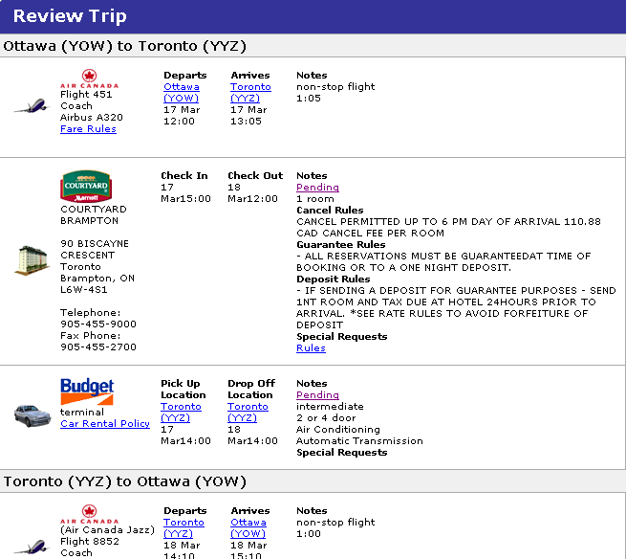  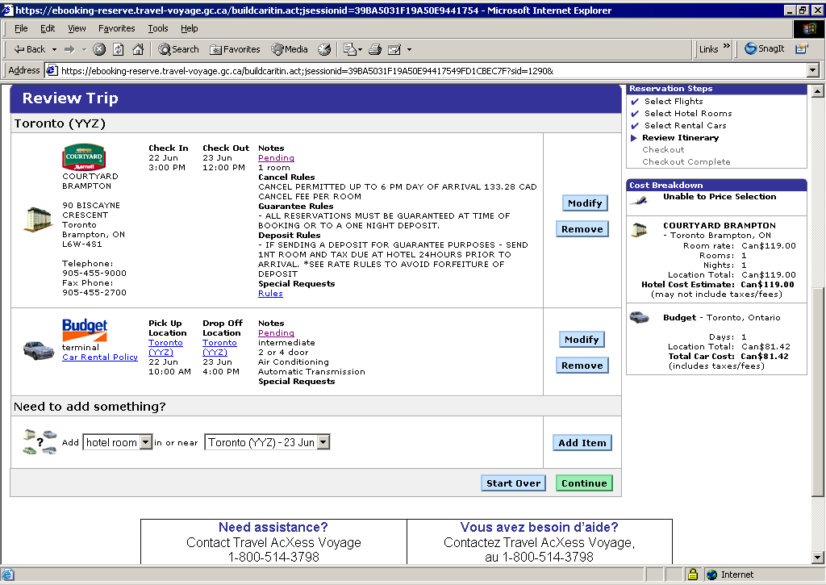 | (Review the hotel reservation information. Pay attention to the rules. You can modify or cancel the reservation).  8.1 Click Continue if you are ready to book the hotel. |  |  | Reviewing trip information  Make sure the check in and check out dates are correct. Check the address of the hotel to ensure you are staying at the correct location.  Special Request  Special requests comes from the Traveller Profile. To change special requests for future trips, make the changes in the Traveller Profile.  Need to add something?  Use this option, if you go on a multi-day trip and need to book more than one hotel for the trip.  For example, you go on a trip to Toronto from the 16th-18th. For the first night you stay in a hotel  downtown. You can enter the dates (16th –17th) and select the hotel for this part of your trip in step 4.  The next night you stay in a hotel in Mississauga. To book the hotel in Mississauga, you would use the Add Hotel Room option. Select the check in time as the 17th and the check out time as the 18th and choose the hotel.
9. Entering passenger information  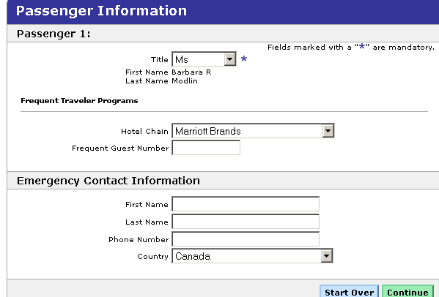 | (From this page, you can enter passenger information including your emergency contact information).  9.1 Click Continue. |  |  | Passenger Information  Personal information from your Traveller Profile is transferred over to the Passenger Information page. If you enter or change information on this page, it will only apply to the current trip.  It is recommended to keep the emergency contact information up to date.  If you have a special need that does not carry over from your Traveller Profile, you may select a special request.  Frequent Guest Number  Enter the Frequent Guest Number manually if applicable.
10. Reviewing purchasing information  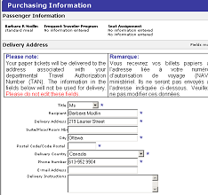 | (Review the information). |  |  | General Requests or Special Needs  Do not enter new information in this field. Remove unnecessary information. This is due to the following reasons:  - counselor intervention is required and will prevent the reservation from automatically going through the system  - a counselor assisted fee is charged to look at the request
11. Purchasing the trip  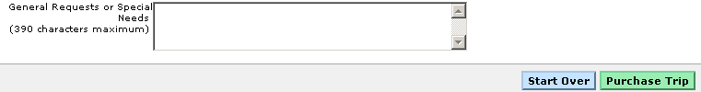 | 11.1 Select Purchase Trip to continue.  11.2 Click OK if you have entered the correct TAN and accept the credit card charge that will appear on the Designated Responsibility Center Travel Card (DRCTC). |  |  | DTC Card  To guarantee a hotel booking, the OBT needs a DTC or personal credit card number. If you do not have a DTC or personal credit card number entered in your Traveller Profile, an error message will appear at the top of the Purchasing Information page. You will be required to enter this information under the Payment Information section.
12. Reviewing the Reservation Complete screen  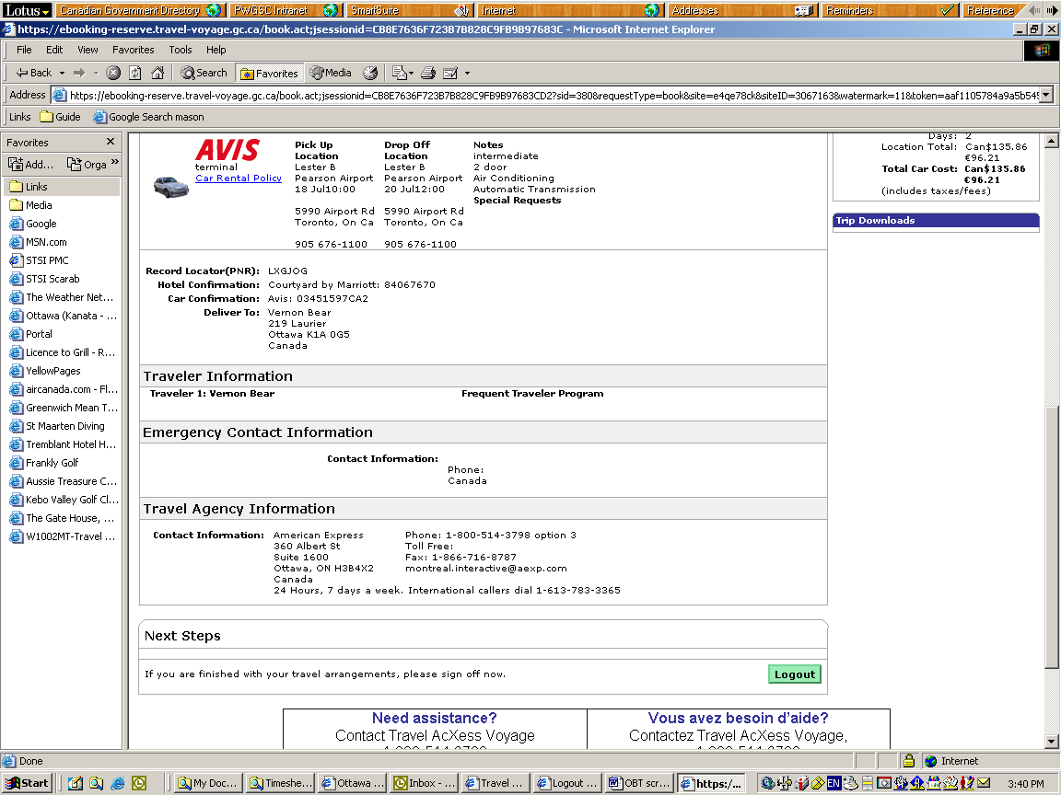 | 12.1 Review all information on this page. Click Logout when done. |  |  | The Record Locator (PNR) number is for reference purposes and proof of reservation (booking). You may provide a travel counselor with the PNR to facilitate any search process.  The hotel confirmation number indicates that the hotel booking is confirmed.  If there is no confirmation number on the Reservation Complete page, check the travel documentation sent to you via your X400 or SMTP email address. If you do not have an X400 or SMTP address, the travel documentation will be faxed.  If the travel documentation does not contain the confirmation number, contact the travel agency prior to departure. Print out a copy of the travel itinerary for your trip.

